User Manual
KYCP features and Process



User Manual
Contents
User Manual 2
2-Step Authentication 4
KYCP Homepage 6
Notifications 7
New Application 13
Search Application 15
Advanced Search 16
Overview/Dashboard 16
Status Flow 18
Add Entity 19
Manual Risk Override 24
Deactivate Entity 26
Edit Fields 26
Further functions within Edit fields 26
Toggle Function - Print 27
Available data types in Edit 27
Organigram 29
Corporate Source Register (Orbis) 32
Screening 34
Printing the Screening Report 34
Documents 38
Automated Expiry notifications 41
Uploading different versions of the same Document Type 43
Export all documents in the application 44
Sorting of Documents with the application and/or entity 45
Single Customer View 45
Physical Copy 45
Verification of documents 45
Review in an Application 46
Score Dial 47
Printing the Risk Assessment 48
Customer Outreach Tool (COT) 49
COT USER view 50
COT Applications 53
COT Users 54
Process - How to onboard a new company in KYCP 55

2-Step Authentication

The system can be accessed on any device and anywhere where Wi-Fi is available. For security purposes, the system can be accessed via a 2-step authentication system.

The user will be directed to the window below when log in credentials are filled in.

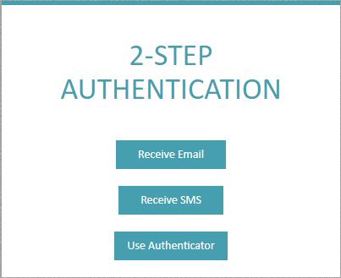
3
2
1

- On pressing ‘Receive Email’, a new window will direct the user to ‘Get Code’. The user will receive a temporary 6-digit code via email to be able to access the system.
NB – ‘RESTART 2FA’ will take the user to the previous window.

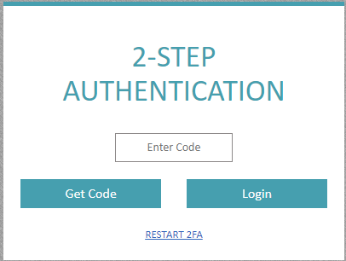

OR

- On pressing ‘Receive SMS’, a new window will direct the user to ‘Get Code’. The user will receive a temporary 6-digit code via SMS to be able to access the system.
NB – ‘RESTART 2FA’ will take the user to the previous window.

OR
- Use Authenticator – Download the preferred Authenticator for Android or Apple devices.

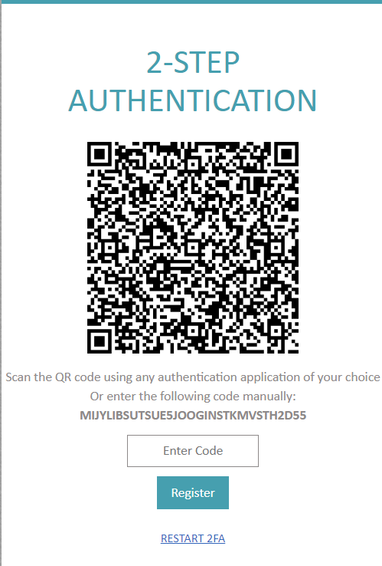
Follow the instructions within the app to register KYCP.
Once KYCP is registered, the user can copy the number generated on the ‘Authenticator’ and key this to the ‘Enter Code’ field before pressing ‘Login’.

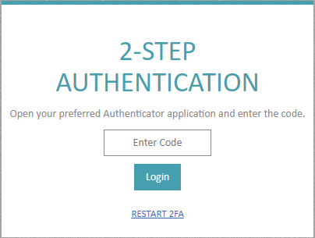

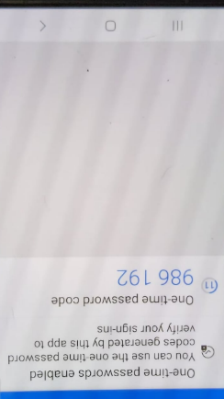

KYCP Homepage

The following is what the KYCP users see on the homepage:
1
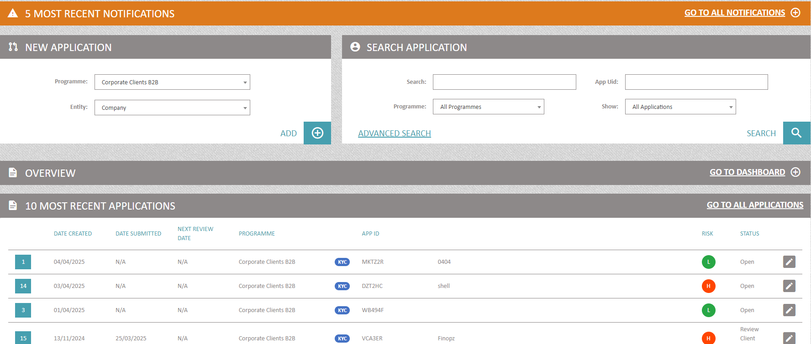
5
4
3
2

- Notifications - these are generated automatically for the specific triggers within
- New Application – KYCP functionality to add a new application within the selected programme
- Search Application – filters to enable searching of an application/entity
- Overview – when opened, the user would be able to view the Dashboard
- 10 Most Recent Applications – list of the 10 most recently created applications. This section also includes the information about to whom the application is assigned to.
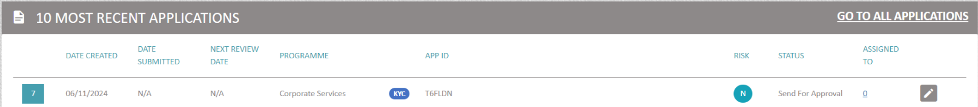
The digit denotes the number of users assigned to the application. When the digit is clicked on, this expands to provide further information (as shown below)
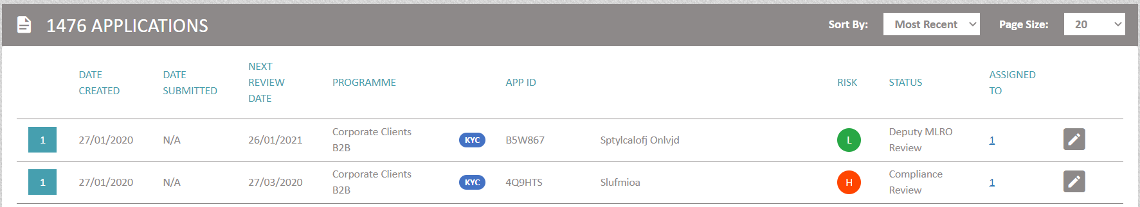
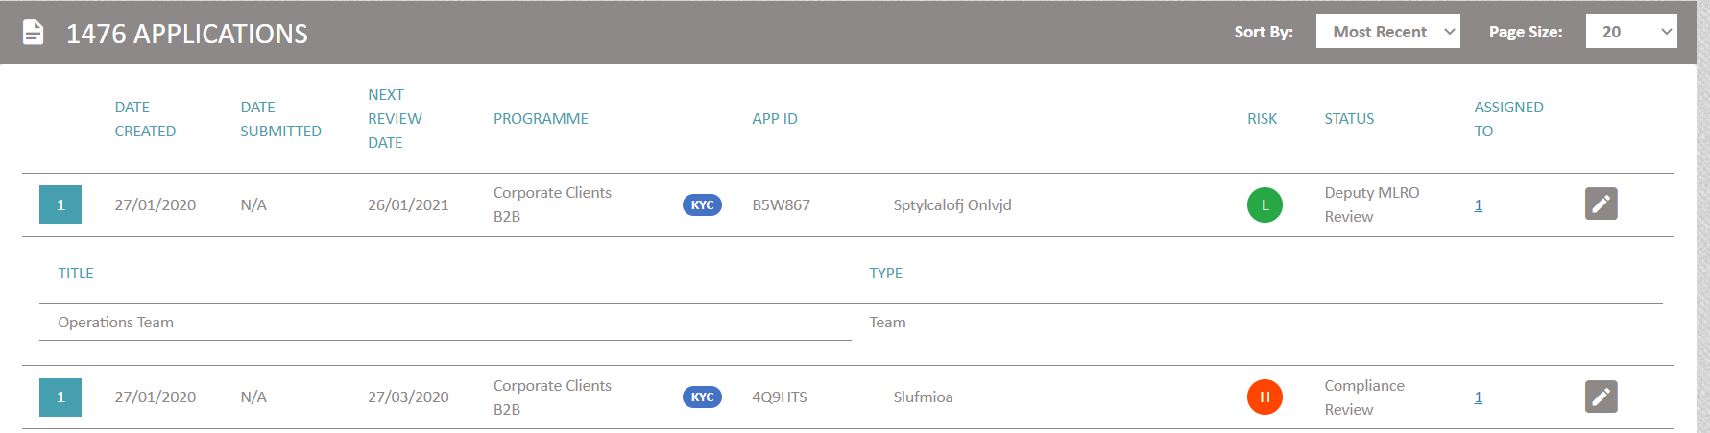
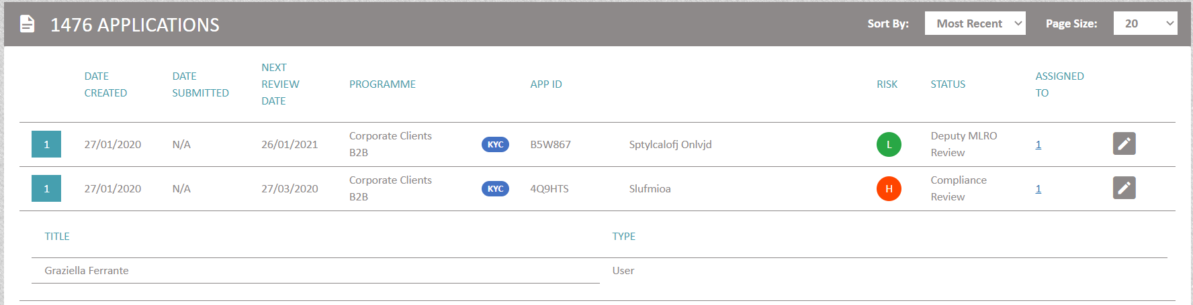

Notifications
Notifications are generated automatically for the specific triggers within KYCP
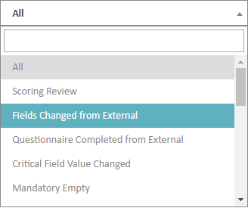
The user can access the full list of Notifications by pressing on the icon on the right-hand side of the panel.
Apart from opening the full list of notifications generated by the system, the user will also be able to e.g., filter according to their requirements etc.
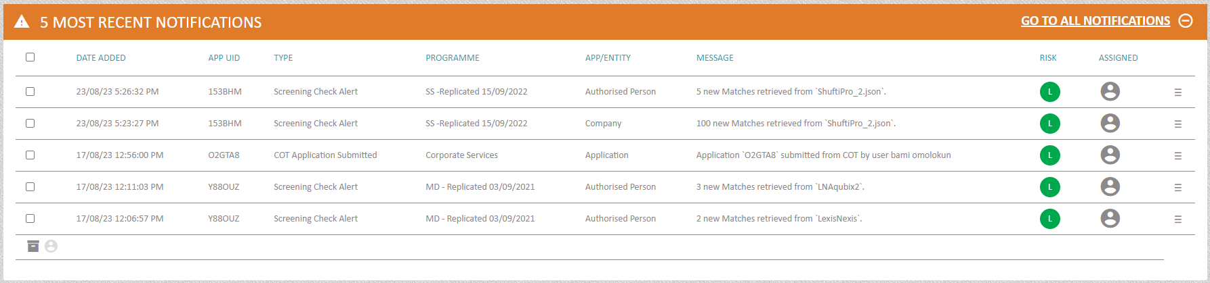
Starting from left to right:
- This gives the user the ability to bulk archive a group of notifications altogether.
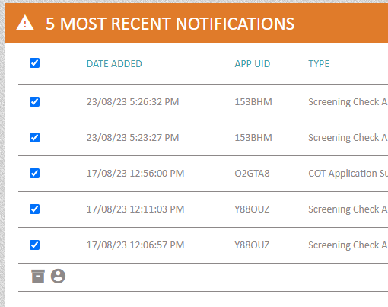
After choosing the notifications and is selected, the system will open a small window where the user will be asked to verify the action.
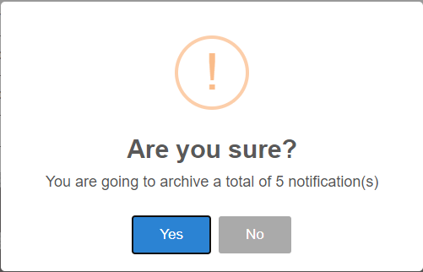
Go To All Notifications: when the user selects this option, the system will open the following in the same tab.
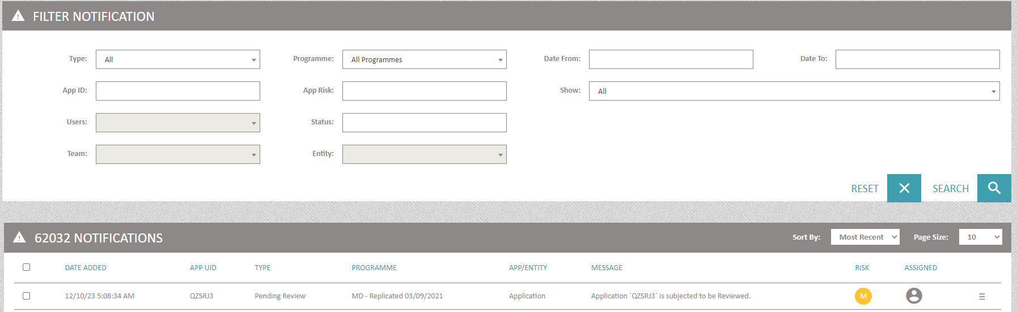
This will enable the user to filter using all or any of the following combinations:
- Type: ‘All’ is system defaulted; however, the user is able to choose the type of notification they want to filter with
- App ID: - system generated application ID
- Programme: ‘All Programmes’ is system defaulted; however, the user is able to choose the programme they want to filter with.
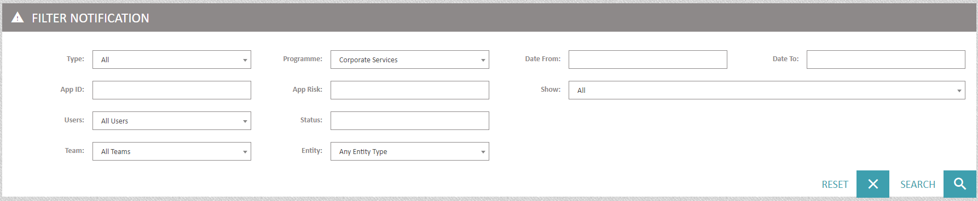
Once the programme is chosen, the user will also be able to filter by:
- Users – ‘All Users’ is system defaulted; however, the user will be able to filter against a selected user.
- Team – ‘All Teams’ is system defaulted; however, the user will be able to filter against a selected team.
- Entity – ‘Any Entity Type’ is system defaulted; however, the user will be able to filter against a selected entity.
- App Risk – user can select to filter a / multiple application risk
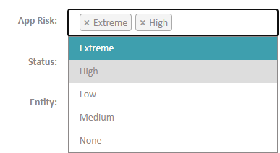
- Status – user can select to filter a / multiple application status/es.
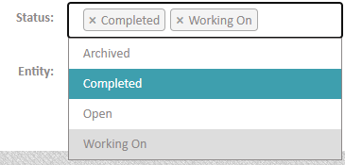
- Date From – write or select date from the calendar
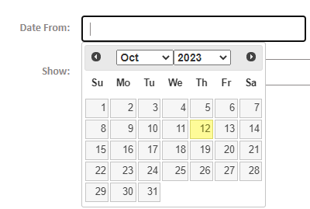
- Date To – write or select date from the calendar
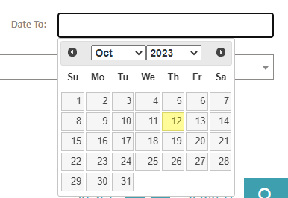
Show – ‘All is system defaulted; however, the user can select an option presented in the dropdown. 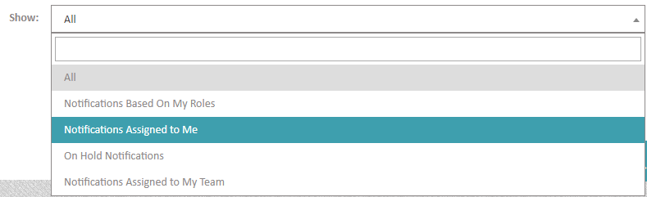
- Sort by: the user can select either by ‘Most Recent’ (default) or ‘Oldest First’
- Page Size – user can select how many notifications to show on the page, starting from 10 (default) up to 100
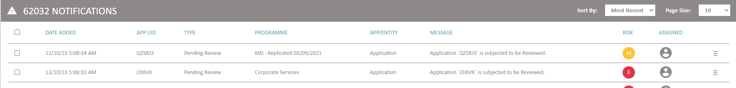
Each notification has a menu, and when the user clicks on the menu icon the following options can be used.
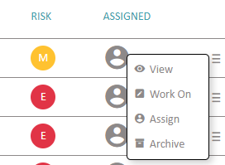
- View - To view a notification, the user needs to press the icon. The user will be asked if they want to open this in a new tab or remain on the same one.
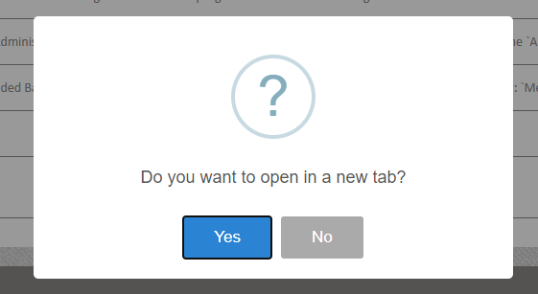
Once the option is selected, the system will open the application and directly highlights the entity to which the notification/s is/are linked to.
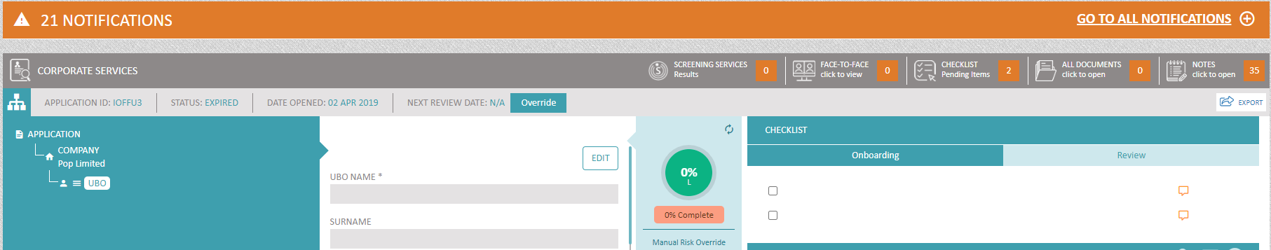
- Archive – ability to archive the notification
The user will also be able to see, work on, filter, archive all the notifications linked to the specific application.
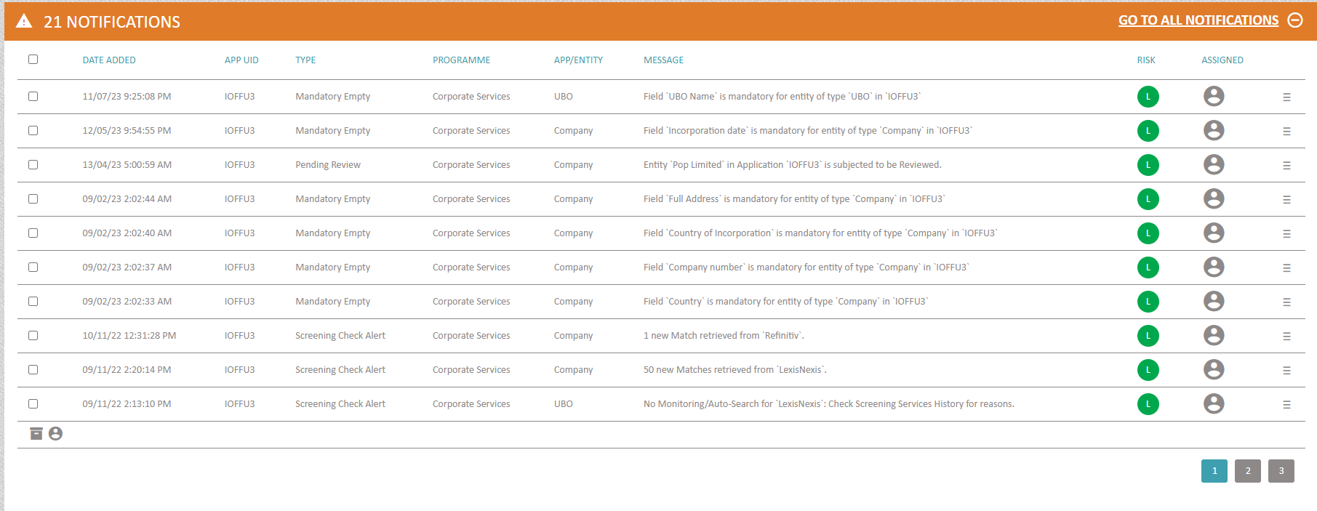

- Work On - Notifications can be assigned to yourself as a KYCP user, and the specific notification can be opened in a new tab.
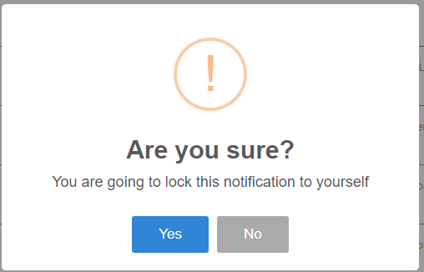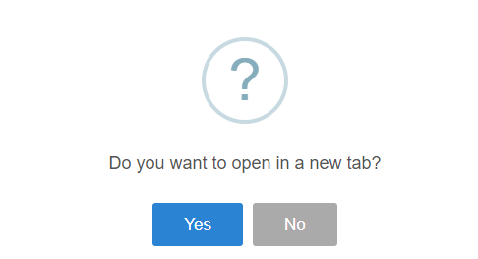
When the user selects ‘Work On’, the notification is highlighted in orange and the , turns green . Hovering over this green person icon will show to which KYCP user or team the notification is being worked on.
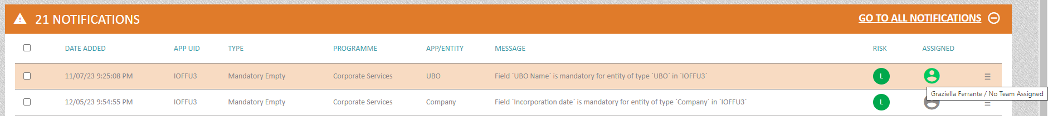
Menu options for the highlighted notification:
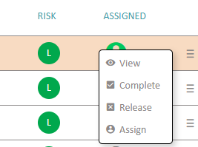
- View – ability to view the notification
- Complete – when the user/team have completed the work needed on the notification, the user/team can select this option. The system will prompt the user/team to answer the question presented in the image. The system will also prompt the user to leave a comment. This action is saved in the audit trail (Notes).
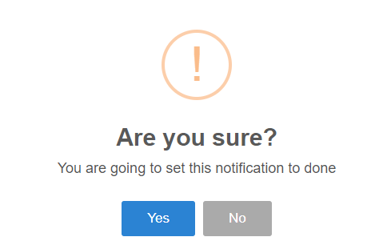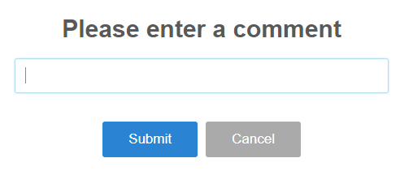
- Release – when selecting this option, the system allows users to remove notifications from being locked to them, the system will prompt the user to leave a comment. This action is saved in the audit trail (Notes). At this point, the notification can be re-assigned to another user/team.
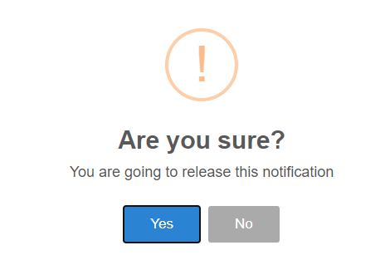
Should notifications apply to the same entity featuring in more than one application, they will be grouped as one.

On selecting the icon, the user will be prompted to a window identifying where the notifications are featuring. Notifications can then be worked on as explained above.
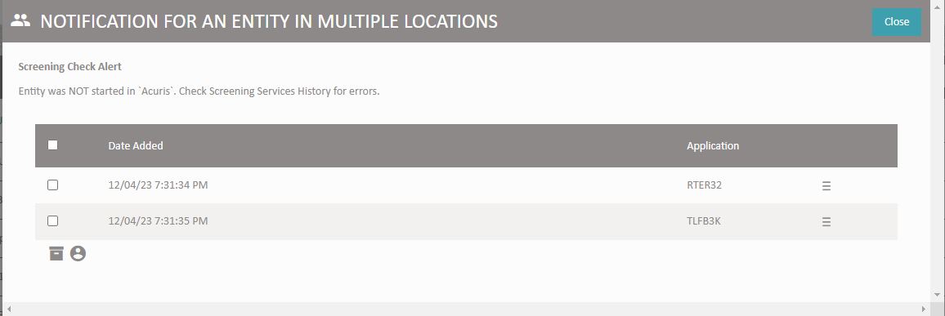
For each notification, the user would have the same options as when working on single notifications.
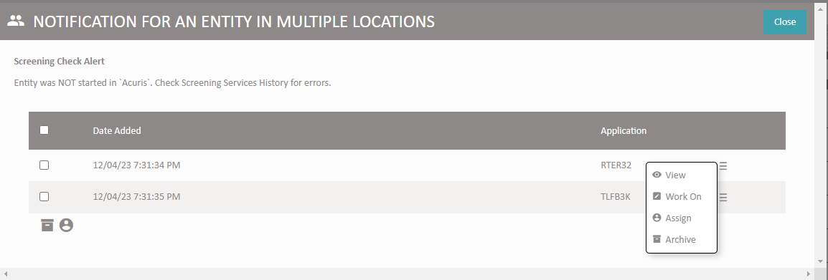

New Application

Each individual client/Root Entity (e.g. Company / Belgian Registered Diamond Company / Trader / Individual) needs to have its own application.
To open a new application, the user must select the relevant programme (if more than one is available), select the Entity type (according to client) and press Add.
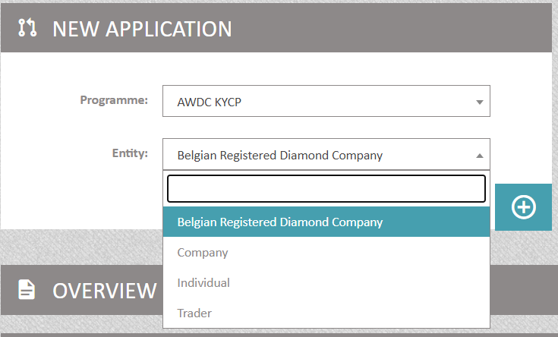
Subsequently, users will be directed to the following screen which will be the “client file”:
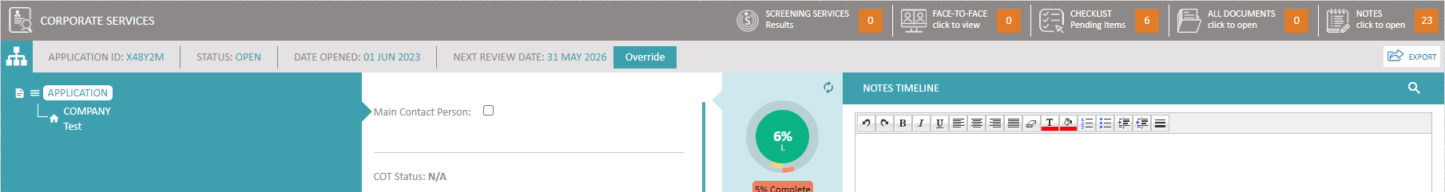
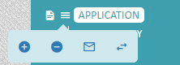

 - Add Root entity

 - Delete Application
 - Email – this generates an email with link/s to fill application fields/upload document/s etc to one or more entities at one go.
When an entity (e.g. Company) is selected, it will be highlighted in white. Next to each entity, users will find 3 parallel lines.
 - Status Override - Allows the user to change the application to any status regardless of the current set-up in the Status module.
When clicking on '⇄' a pop-up window comes up with a dropdown list of the statuses configured within the programme.
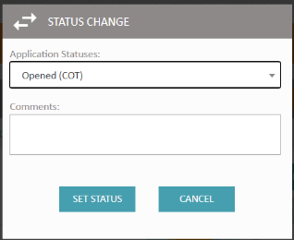
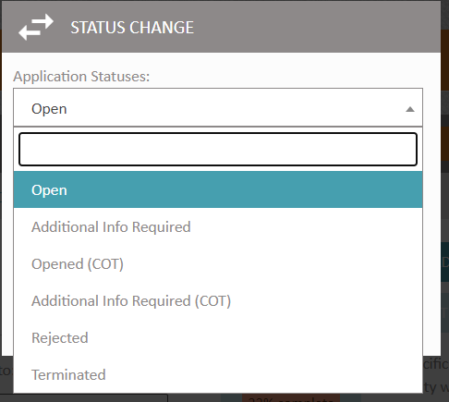

Once the user chooses the status they want to move the application to, they need to leave a comment in the text box and select ‘Set Status’
Clicking the parallel lines (per entity) opens a mini menu.
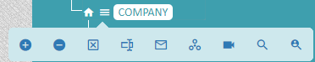

Starting from left to right:
- Add entity/ key principle under the root entity
- Delete selected entity
 - Deactivate entity – to be used when the entity e.g., shareholder is no longer an active entity. In this case, the entity’s information is retained but the entity per se will be ‘greyed’ out.
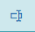 - Edit Fields used to edit all the fields in the ‘second column’ of the screen pertaining to each entity.
 - Email – this generates an email with link/s to fill application fields/upload document/s etc to the selected entity directly within the system. (NB – for this feature to function the email address and mobile number are required)
 - Organigram – KYCP’s dynamic function to generate in real time the corporate structure within the application
 - CSR Search - this allows the user to search/ view/ import information from third party company houses which would have been integrated with KYCP (CSR -> Corporate Source Register)
 - when this icon is selected, the system will search for the highlighted entity – if linked - across all the applications. The user can access the applications where the linked entity is featured by clicking on the ‘pencil’ icon. The system will open the selected application in a new tab and will also highlight the entity.
The user can also download a CSV file to capture the generated report by selecting the ‘print’ button. The file can then be saved in the user’s preferred folder.
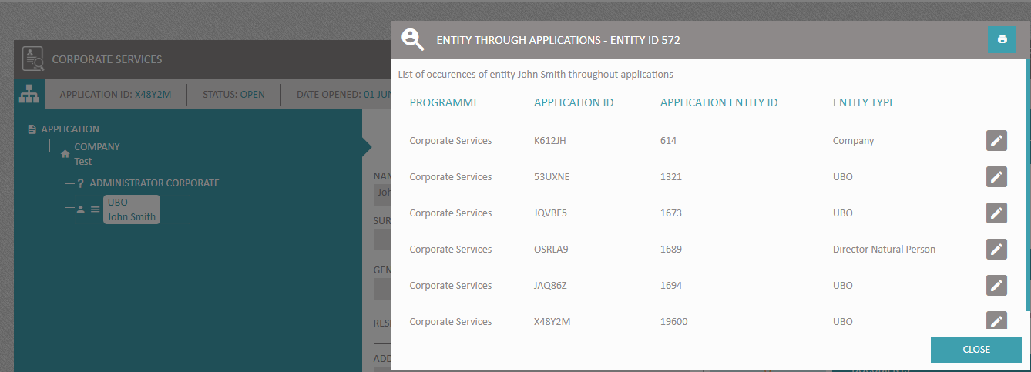

Search Application

Applications can be searched e.g. Name & Surname for Natural Person or Name for Legal Person, or by the Application ID (App Uid) or bring up matches in any field of type String or Free Text
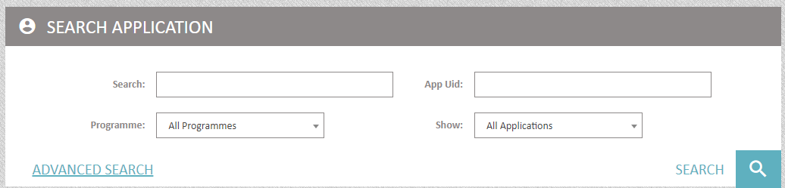
Users have the option to search with the exact criteria e.g. Name / Surname or opt for any of the Wildcards.
The “wildcard” is an advanced search technique that can be used to maximize the user’s search results within the system. Wildcards are used in search terms to represent one or more other characters. The most commonly used wildcard is an asterisk (*), which may be used to specify any number of characters.

Advanced Search
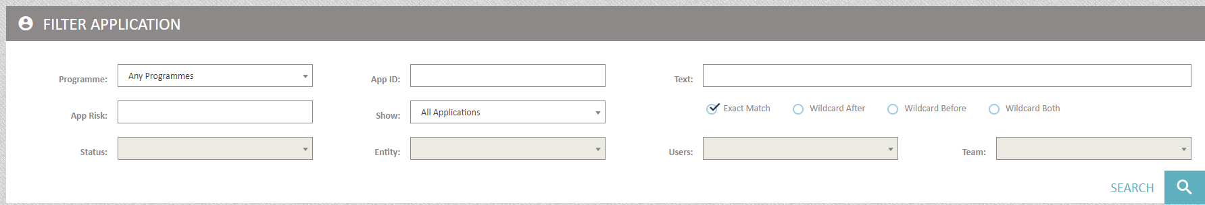
KYCP allows further granular filtering through the Advanced Search. NB: The below will remain ‘greyed out’ until a specific programme is selected in the ‘Programme’ field
- Status
- Entity
- Users
- Team
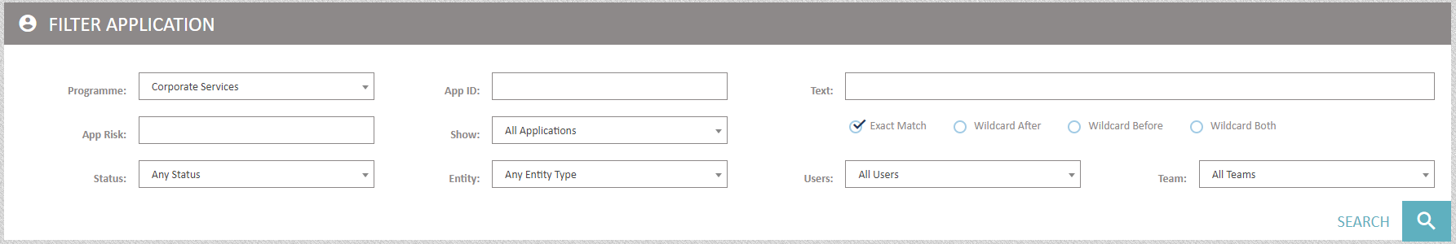
Advanced search allows filtering through the following settings:
- Programme – Programme Name
- App ID – application ID
- Text – data filled in fields of data type String or Free Text e.g. Name & Surname
- App Risk: Application Risk. One of the following options can be selected:
None
Low
Medium
High
Extreme
- Show – filtering can be done by selecting one of the following options:
All Applications
Applications Based On My Roles
My Applications Only
On Hold Applications
- Entity e.g. Company, Director etc
- Users e.g John Smith (KYCP user)
- Teams

Overview/Dashboard

This can be viewed as part of the home page
If the  icon is pressed, this will display two of the charts generated by the system
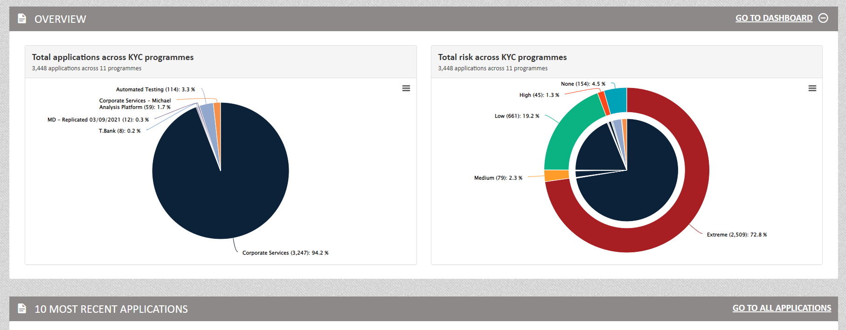

OR - open MENU – found on the top right corner of the Home Page and select the Dashboard tab.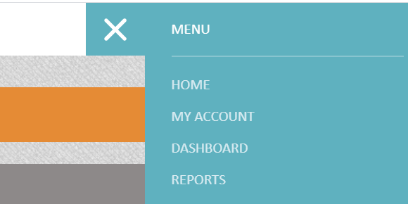
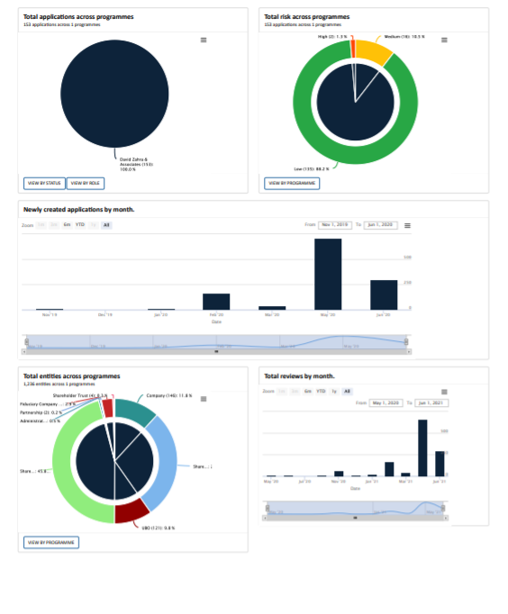
This chart gives the user an overview of when the applications are coming up for review
This chart refers to the entities which were created within the applications
This chart refers to when the applications were opened. The user has the option to narrow down the time period
This refers to the risk the applications are featuring
This refers to the number of opened applications across the system

Through the dashboard, the user can also select to view applications which are of status type ‘Open’ (default), ‘On Hold’ or ‘Closed’. These can be used in combination, or single select or selected all
The following images are examples for comparison –
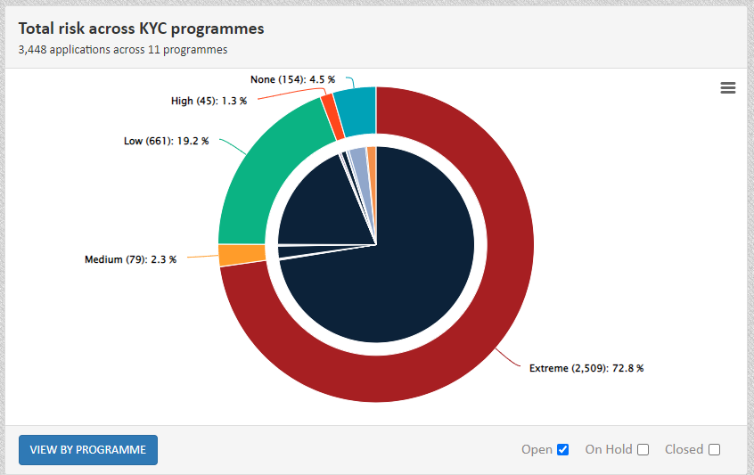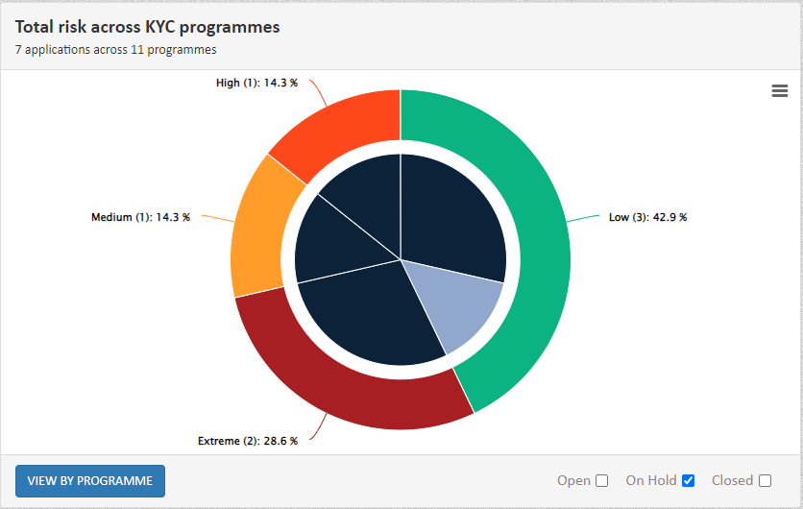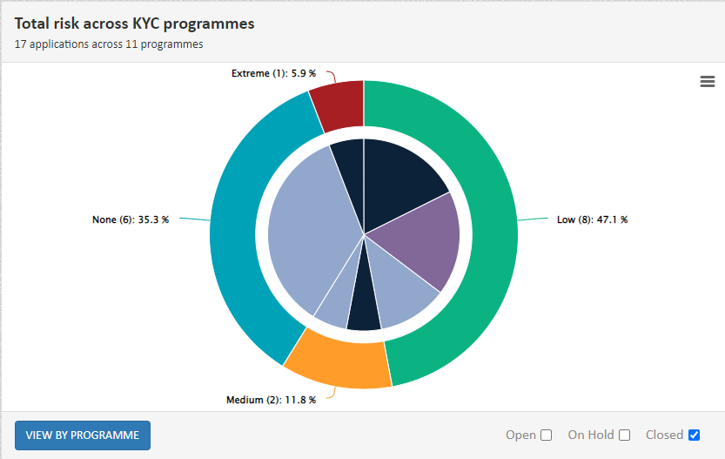
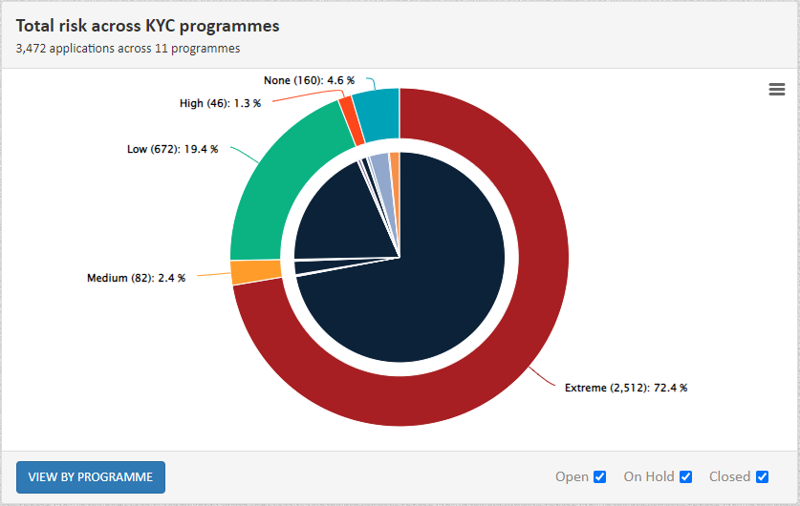
Individual charts have other filtering
- Total applications across KYC / CM programmes – ‘View by Status’ & ‘View by Role’
- Total risk across KYC / CM programmes – ‘View by Programme’
- Total entities across KYC / CM programmes – ‘View by Programme’

Status Flow

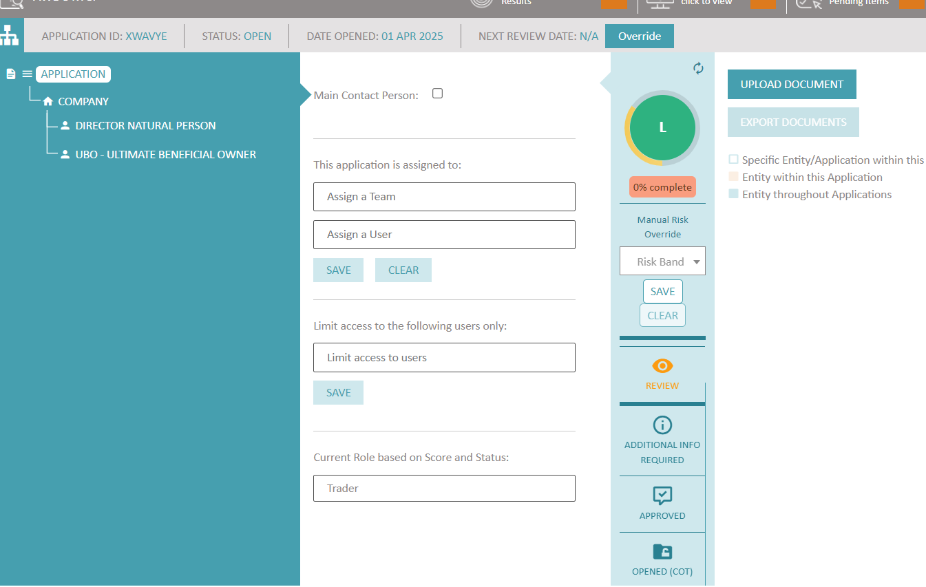
Statuses are set to identify at which stage the application is, from its creation ‘Open’ till the application is closed -> Rejected/ Terminated.
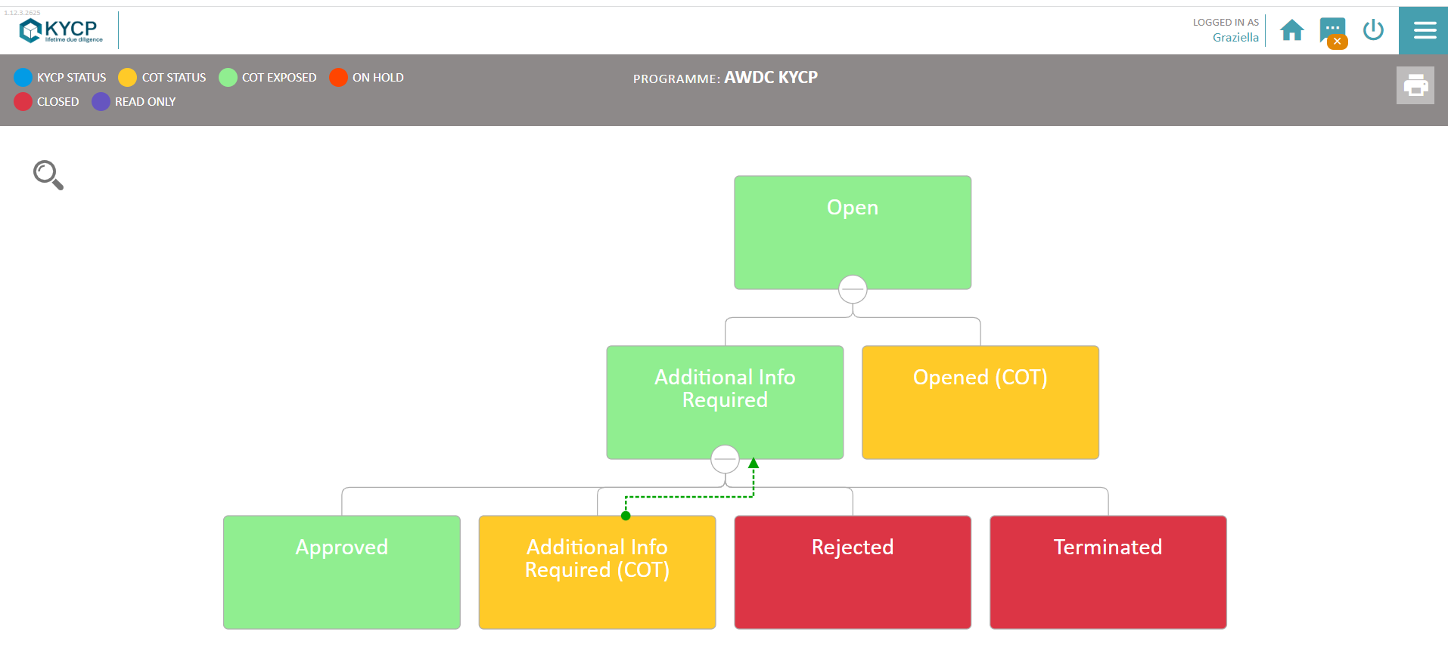
NB – statuses ‘Rejected’ and ‘Terminated’ - When either of these statuses is selected, the application will be closed forever on KYCP and cannot be reverted to another status. Although fields can be populated / amended and documents uploaded etc, the rest of the functionalities of the application will be ‘frozen’ to the time when the application was set as closed.
Whenever a status is selected, the user needs to leave a comment.
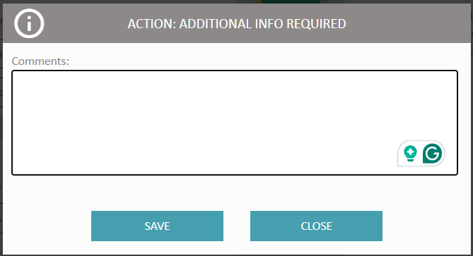

Add Entity

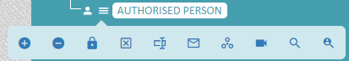

This icon enables users to add entities that lie behind the Root entity (e.g. Company / Belgian Registered Diamond Company / Trader / Individual) i.e. the client and that makes up the structure behind the client, (e.g. behind the customer entity Company, users may want to add the persons that lie behind the company such as UBO, Director, etc…). The same feature allows users to add child/ren entities to those entities where child/ren entities are allowed. Users will be prompted to choose whether the entity they are adding is a “New Entity” or “Existing Entity” or “Clone an Existing Entity”.
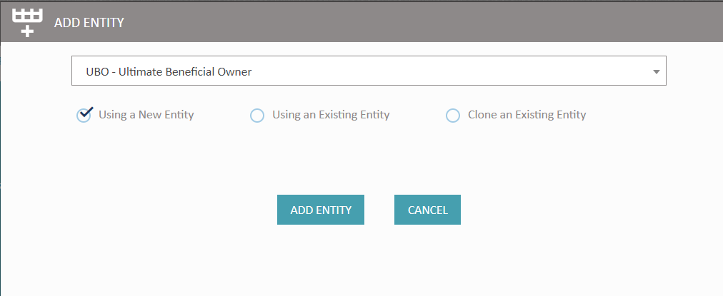
On selecting “Using an Existing Entity”, users will be prompted to choose from one of the matching existing entities following which the details of the existing entity will be automatically uploaded in the new entity being created.
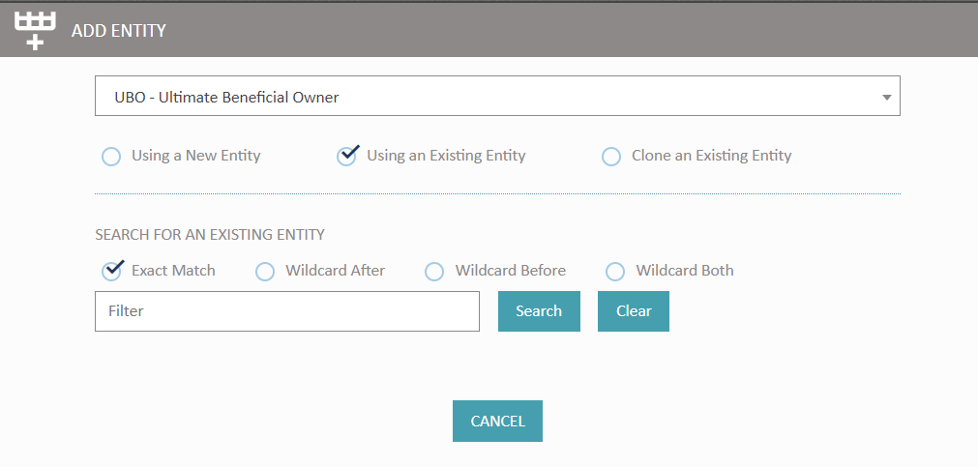
Entities under the root entity can be added according to the ownership of the ‘client’. A simple tree structure – Company (client), Director Natural Person, UBO – Ultimate Beneficial Owner - would look like the following example.
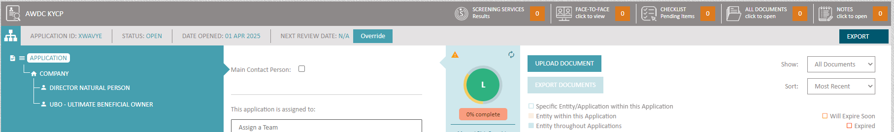
In the case of existing Legal Persons KYCP, these can be added with all the involved ‘children’ e.g. / Shareholder Natural Person, UBO – Ultimate Beneficial Owner etc.

The icon displayed next to the entity type is as follows:
- icon displayed for when the entity category is Legal Entity
- icon displayed for when the entity category is Natural Person

The process is as follows:
- Add entity, choose the desired Entity, and select Using an Existing Entity
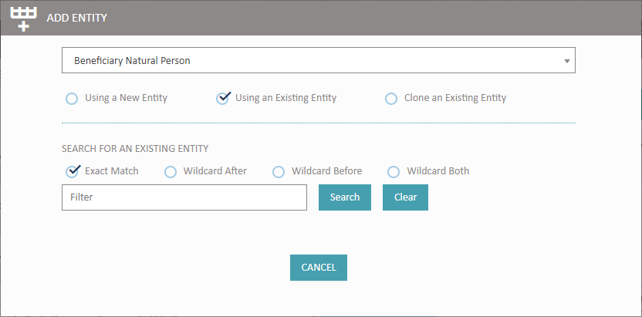

Press Search for the existing entity

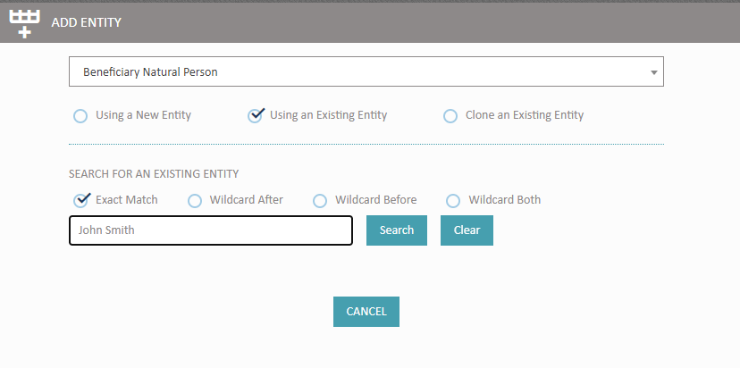
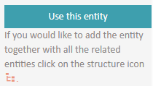
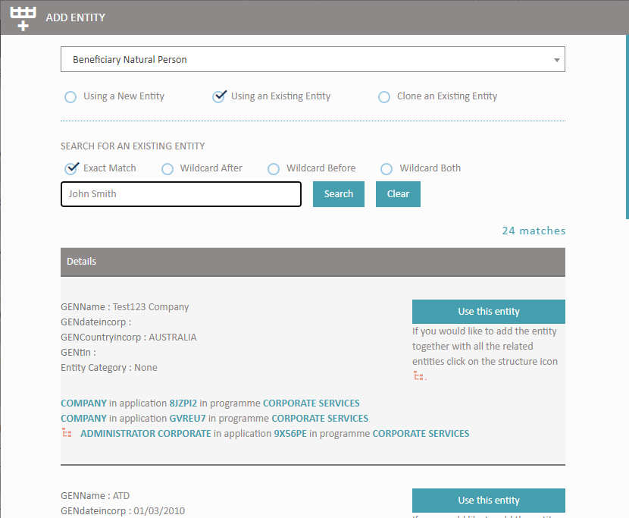
Search Results
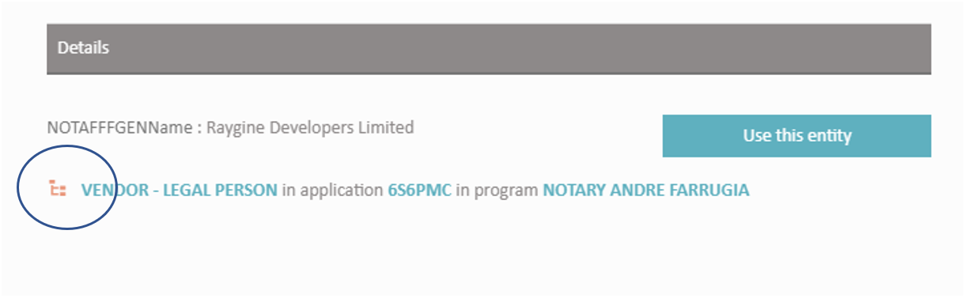

3. When the results come up for legal persons, take note of the Toggle Structure icon (circled in the above image)

4. Press the Toggle Structure and add the suggested structure (before adding the user will be given the option to change the designation of the entity e.g., from UBO to Shareholder Natural Person should this be required)

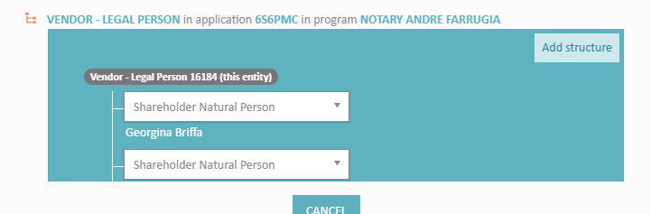

At this point, all the tree structure under the existing entity will be automatically added.

NB: If an entity e.g., another Shareholder Natural Person is added to the structure - this is NOT automatically added in structures of the other applications.

Clone an Existing Entity:

Similar to “Use from Existing”, this lets a user search for existing entities, but in this scenario, instead, the resultant entity will only be a clone of the original, it will not be linked/synchronized with the original.
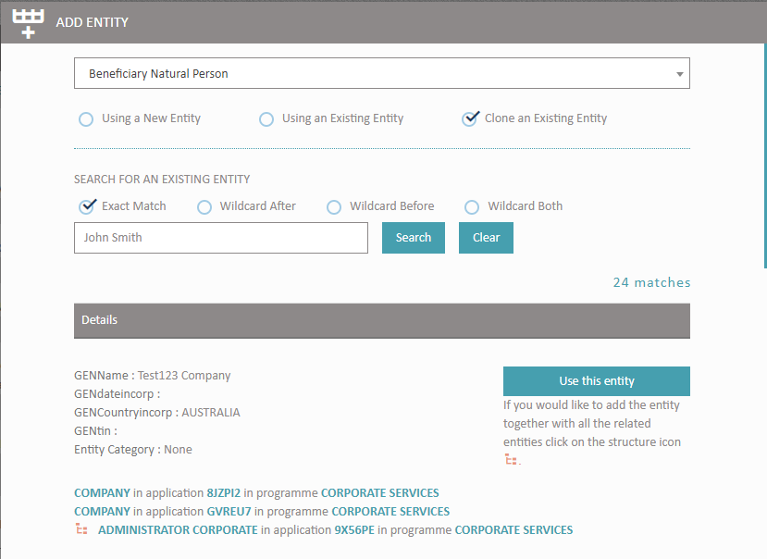
The clone would be created with all the same information as the original excluding the “Name” & “Surname” in order to avoid duplicating entities, the user would need to fill up this information.
NB: This feature allows ONLY the fields to be cloned.

Manual Risk Override

The user will be able to change the overall risk of the selected application. This feature is found at application level under the score dial presented in the 3rd column of your screen.
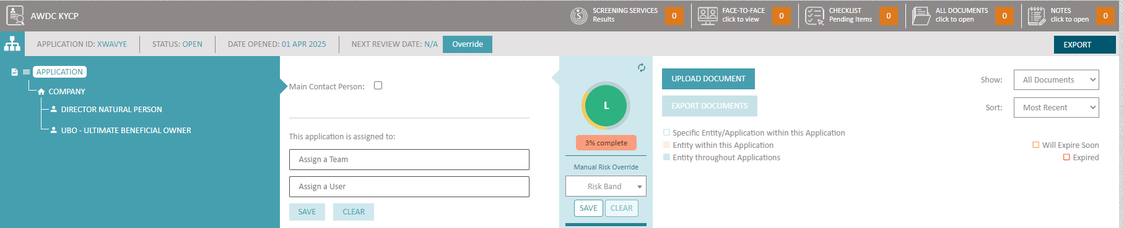
The user will be able to lower/increase the application risk. Once this feature is used, a notification will be fired indicating this change.

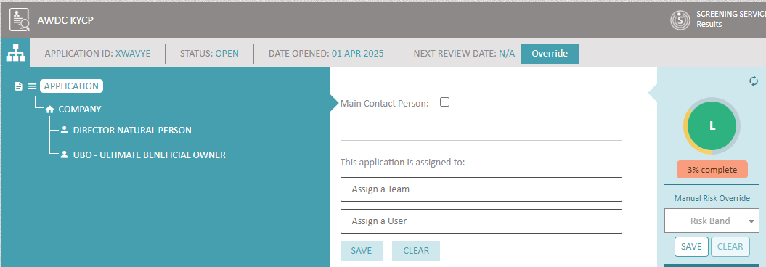
Application score before Manual Risk Override

The system will prompt the user to leave a comment when manual override is being done at application and/or at entity level.
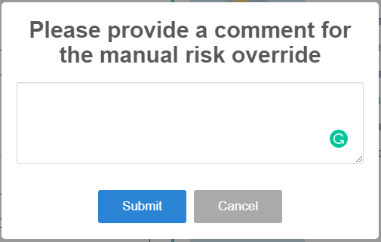
Once the user presses ‘Submit’ the system will alert the user that the change was successful.
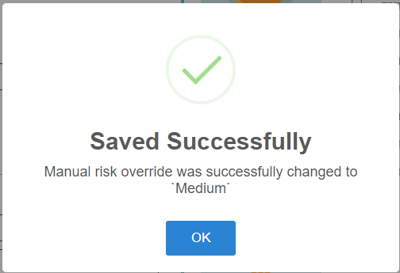
Manual Override changes and comments left by the user are recorded in the audit trail [Notes].
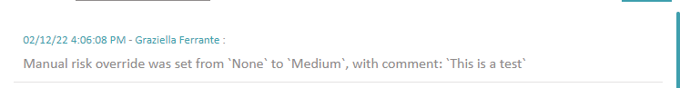
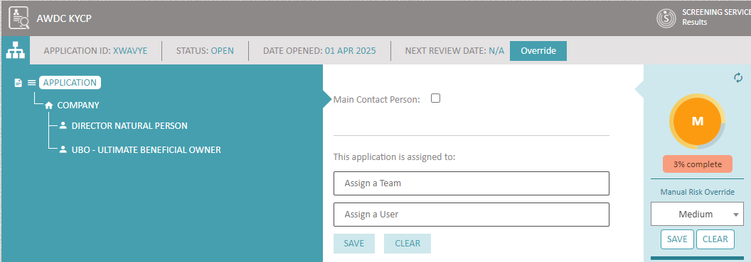
Application Risk after an override with Medium risk was done

The system will fire notifications should the original risk become lower/higher.

Deactivate Entity
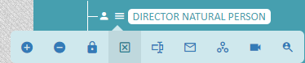
When an entity is no longer an active member of the structure, KYCP user can deactivate it. All KYCP functionality will be disabled however all information, risk, documents etc will be available to view. A deactivated entity can be activated again.
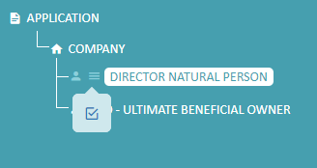

Edit Fields
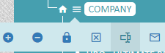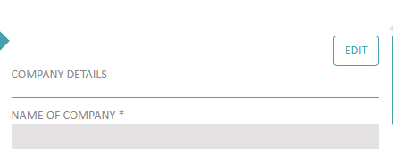
Users need to select one of the icons shown in the images above, to be able to populate (& eventually amend when the need arises) the answers to the application fields.

Further functions within Edit fields
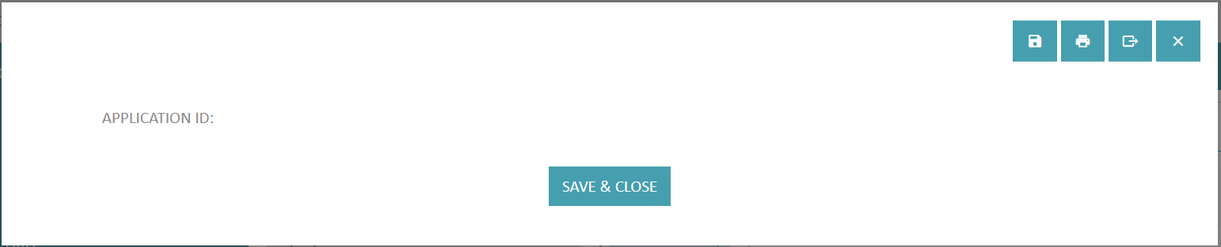
 Save – ability to save the fields without closing the window
 Print – ability to print the fields

Toggle Function - Print
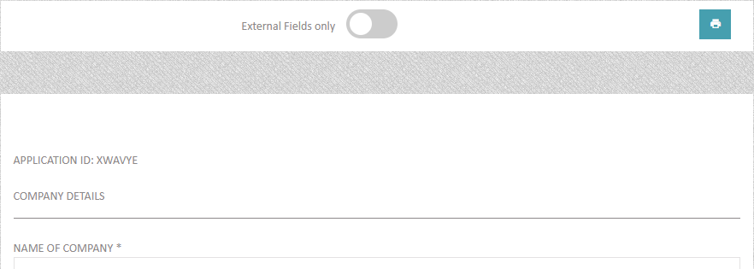
When printing the fields of a specific entity within KYCP, you can now toggle whether or not you want to exclude fields marked as Internal, or all fields regardless of Internal setting.
Open – Functionality which opens the entity fields in a new window. NB Entity fields will not be updated automatically when the editor is opened in a new window.
 Close – ability to close the editor without saving
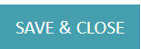 Save & Close

Available data types in Edit

String – alphanumeric characters in a small box. This data type is also used for mobile numbers & telephone numbers.
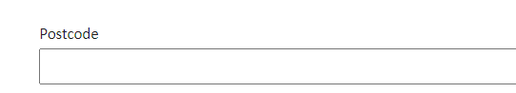
Free Text – alphanumeric characters in a big box
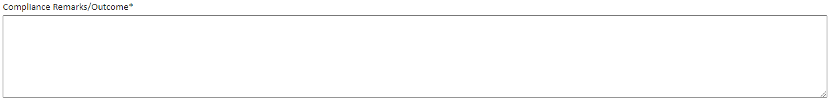

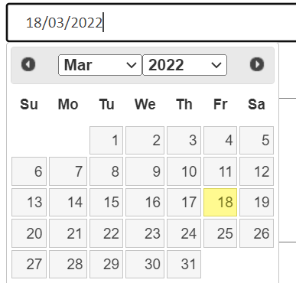
Date – Dates (format – DD/MM/YYYY) or chosen from the calendar provided

Lookup – data in a drop-down list format
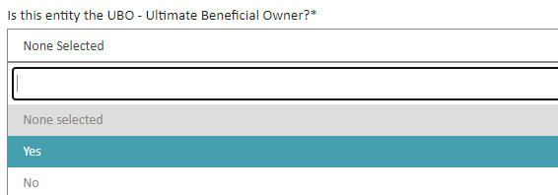

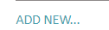Add New – this can be found to any data type which allows multiple answers
Complex types - are groups of fields which can repeat themselves together e.g. ID Type, ID Number, ID Expiry Date fields being grouped within a complex type since more than one ID document can be presented.
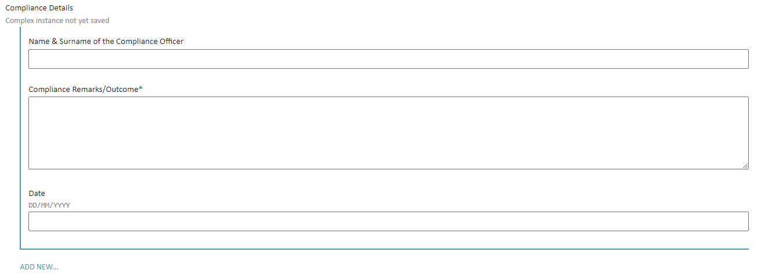

Once populated and saved, the system will show the number of instances the complex was used, and it will also show the instance IDs for each.
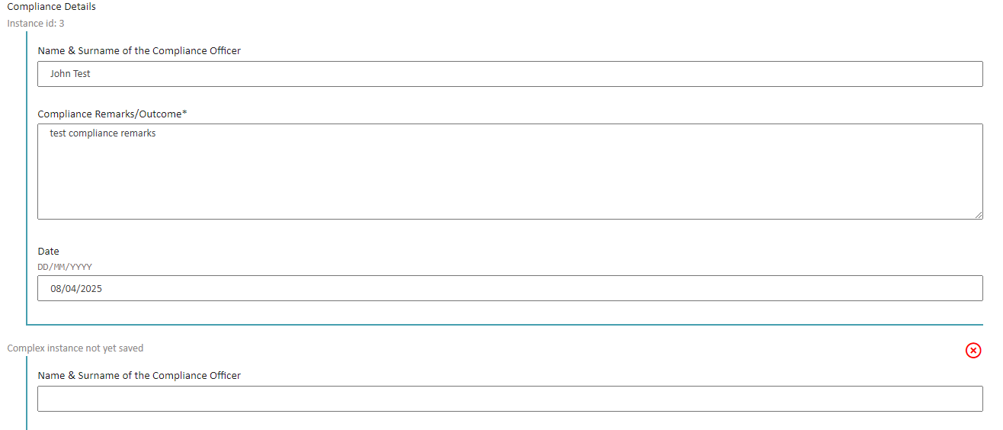

Title - a divider/header used for formatting purposes to indicate the title of a section for example. No data can be inputted here. These can be expanded/collapsed, however by default the ‘Title’ is expanded, leaving the KYCP user to collapse where necessary.
Image showing all the fields under the title (expanded)

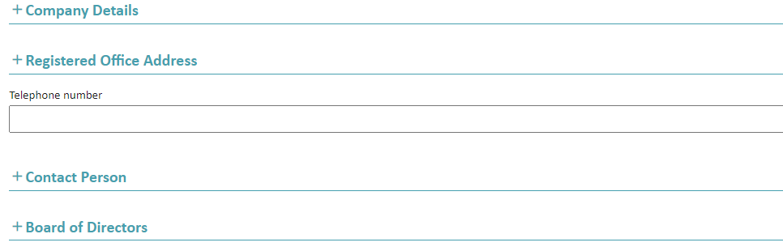
Image showing some 'collapsed' titles and another 'expanded'

Statement - a statement used for informational purposes to guide the user or give more details where required. No data can be inputted here.

Organigram
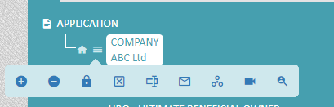
When selecting this icon, KYCP user will be taken to another window showing the relationship between entities.
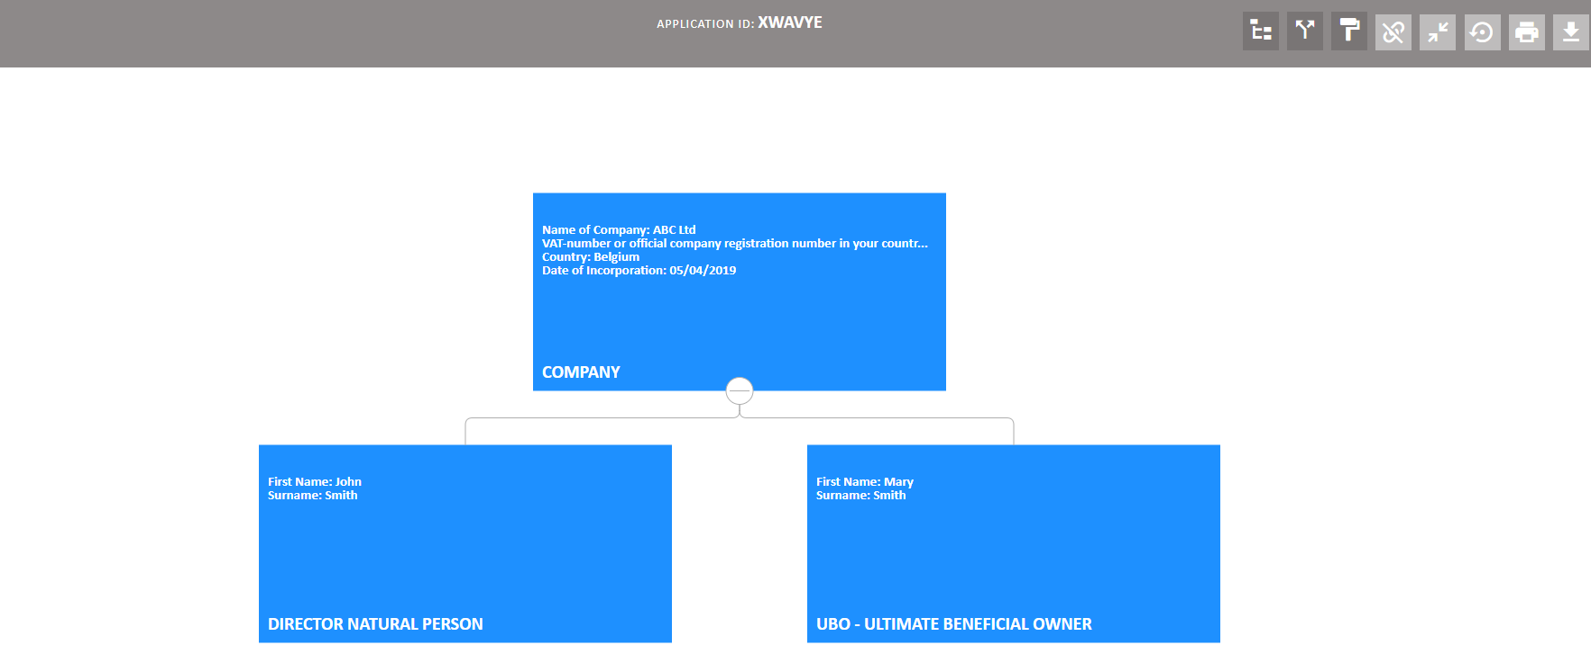
 - flips the organigram vertically
 - adds/removes all colour
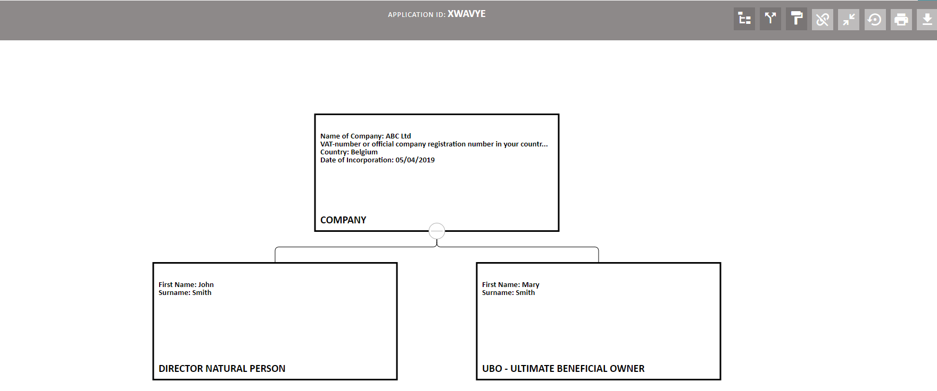
 - Shows where the same entity exists across different applications/programmes in KYCP.
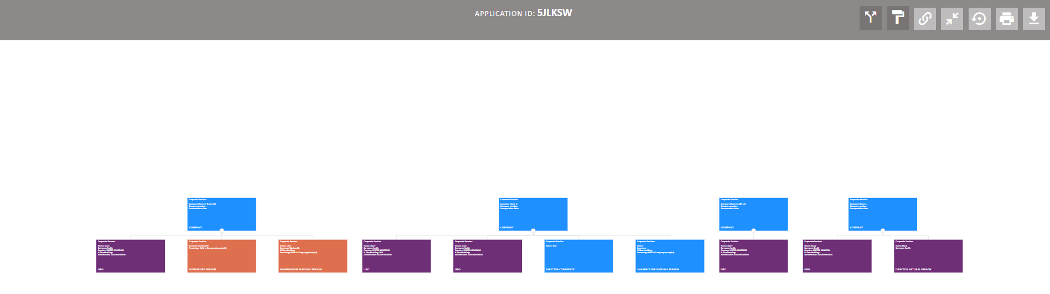
NB: The link will be done across ALL programmes even though the user might NOT have full access to all programmes. However, the system will alert the user that access is denied if the user attempts to view the application from other programmes that they do not have access to.
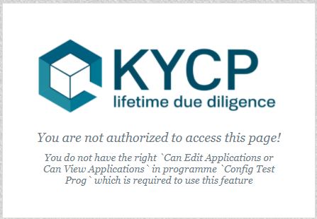
 - Expands/collapses organigram
 - Restore. This restores the organigram to its original state.
 - Print. This requires the name of the signatory, which will be added to the printout
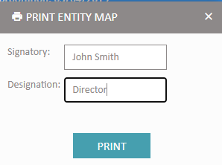

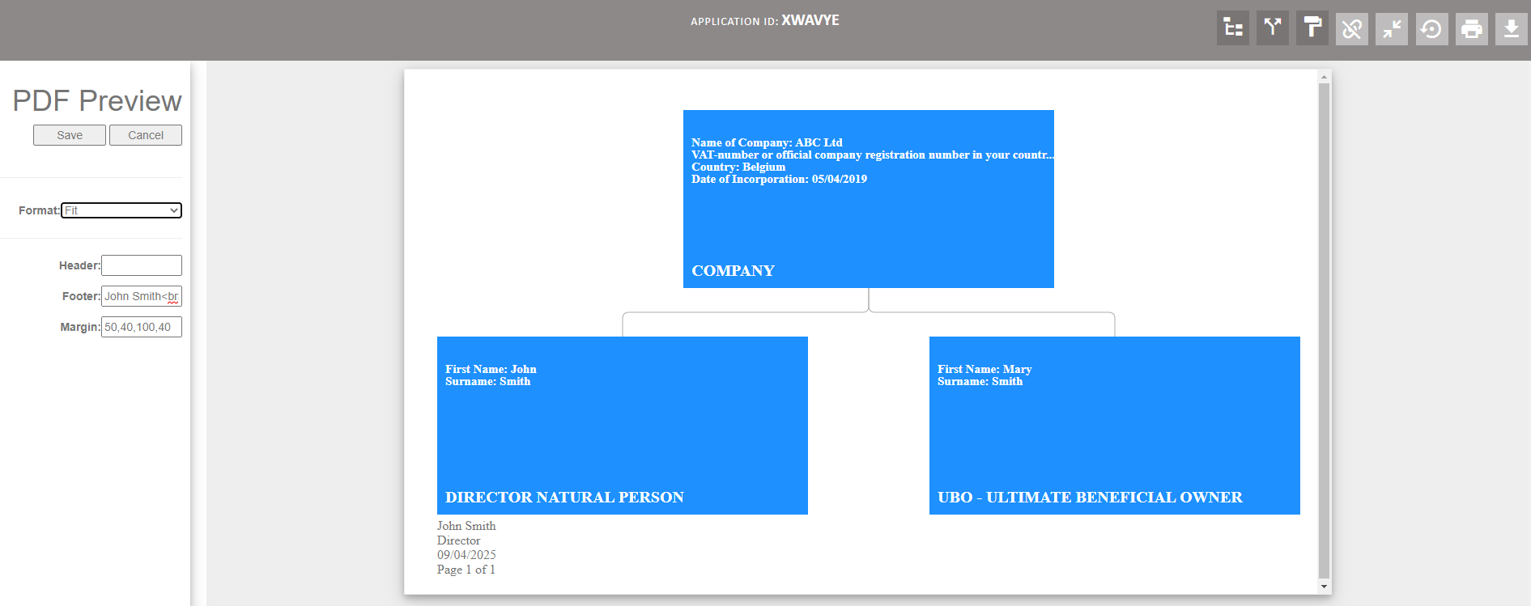
 - Download

Corporate Source Register (Orbis)
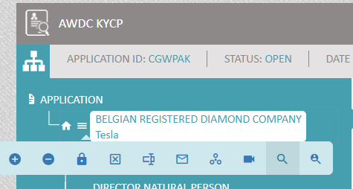 OR 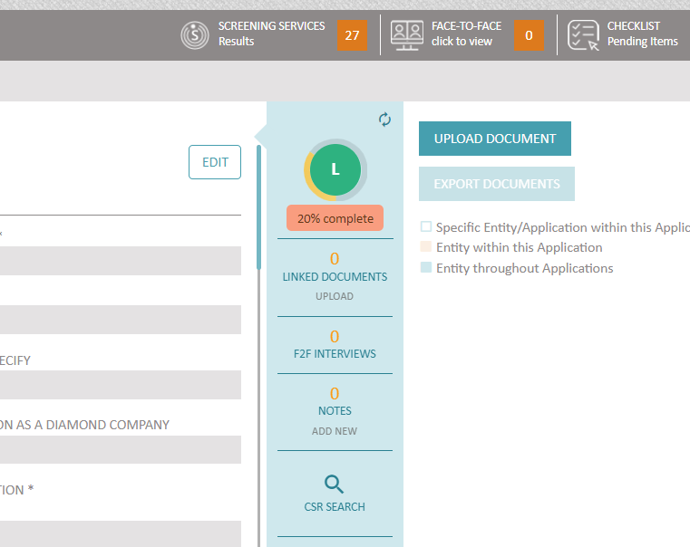
CSR Search - this allows the user to search/ view/ import information from third party company houses which would have been integrated with KYCP (CSR -> Corporate Source Register)
Once selected, the system will open the CSR Search window:
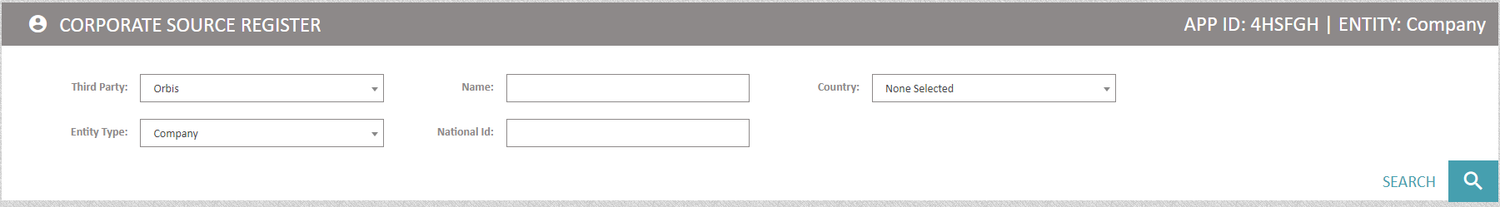
Third Party – indicates which 3rd party is integrated with KYCP
Entity Type – Company or Individual can be selected
Name - Enter the name of the company/individual
National ID – (optional) insert the National ID if the Entity is an Individual
Country – (optional) select the country from the list provided

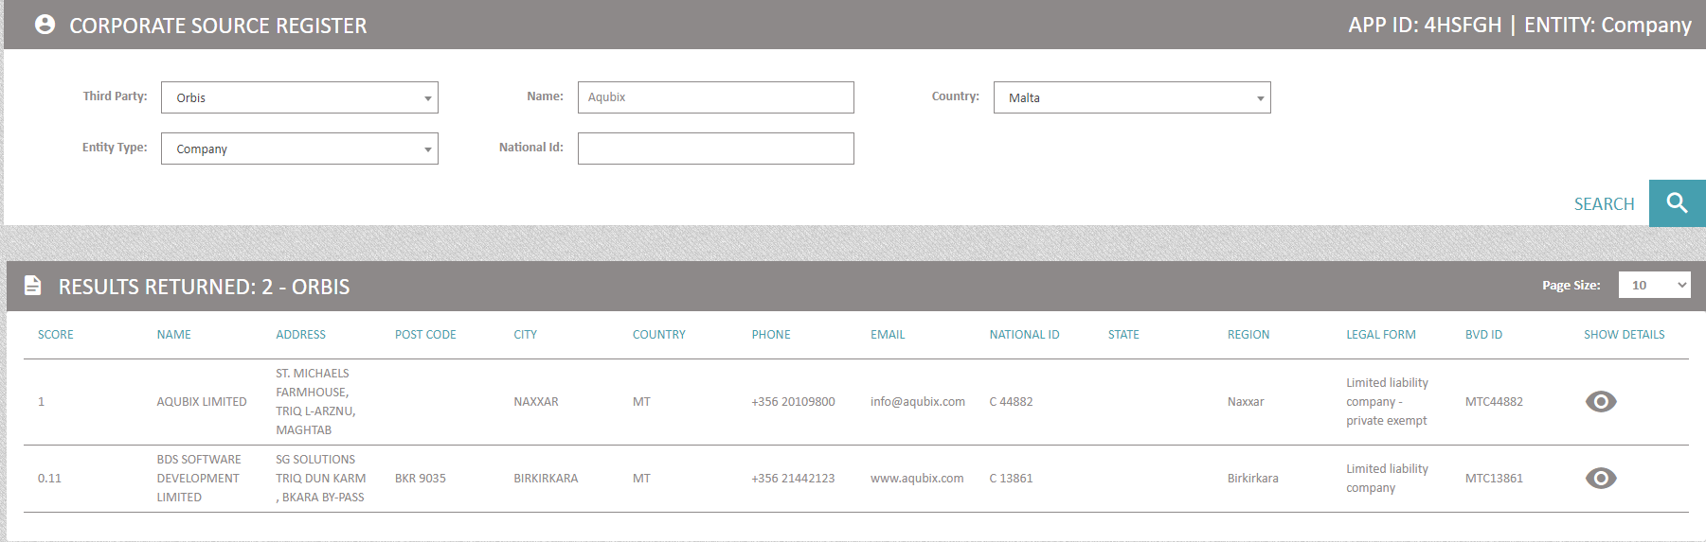
sample of results rendered from CSR

On selecting SHOW DETAILS – the system will open another window
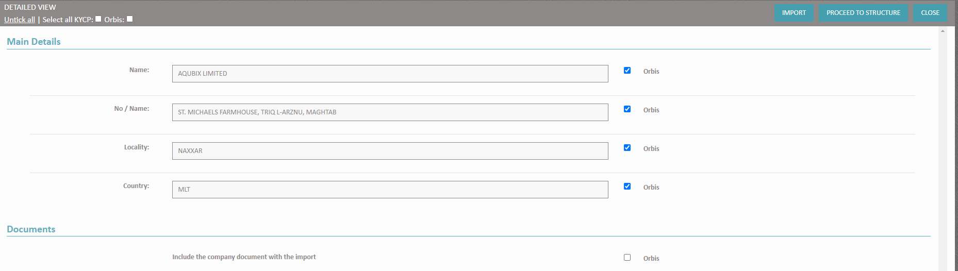
NB - first select 'Import' and then select 'Proceed to Structure'
NB: Before selecting ‘Import’ scroll down the window and select 'Documents’ and ‘Monitoring’
The details under the title Main Details depend on the fields mapped between KYCP and the 3rd party.
Any documents available on the 3rd party system will show under the title Documents.
The selected fields/documents can be imported to KYCP by selecting Import.
Proceed to Structure will take the user to the next window
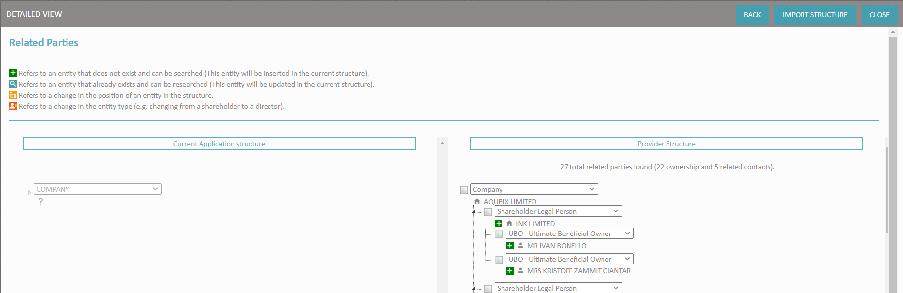
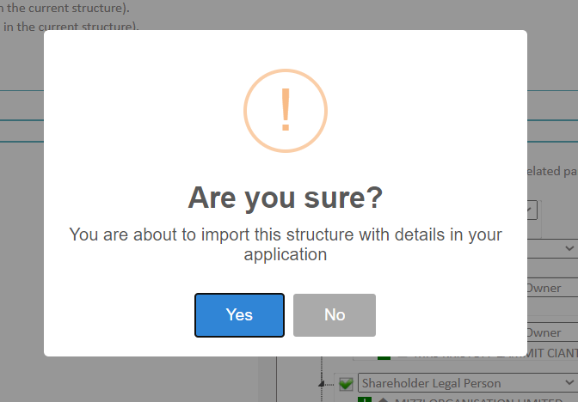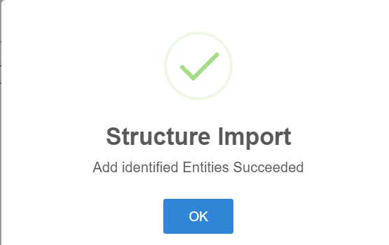
The whole structure of the Legal Person will be displayed in this window. The user can select part of/the whole structure and on clicking Import Structure, these will be added to the treeview in KYCP
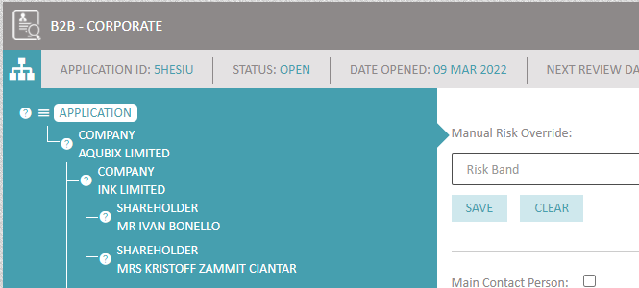

Screening

To view results, users must select the relevant entity and select the Screening Services button. Results will be shown in the 4th column as per picture below:

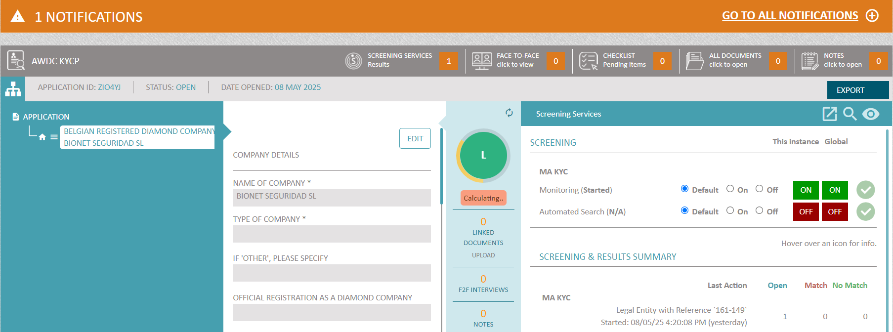
To view the specific detailed results, users must click on the ‘eye’ icon that appears on the right-hand side of the screen (also seen below)
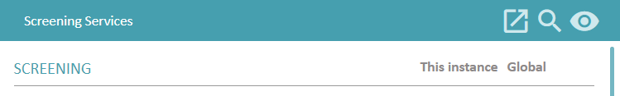
Conduct a new search
View results

Printing the Screening Report

- Select the entity from the tree structure (column 1)
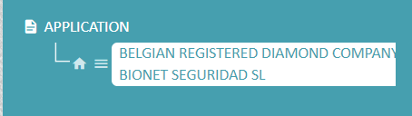

- Select Screening Services from the top task bar (click to view)

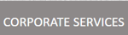
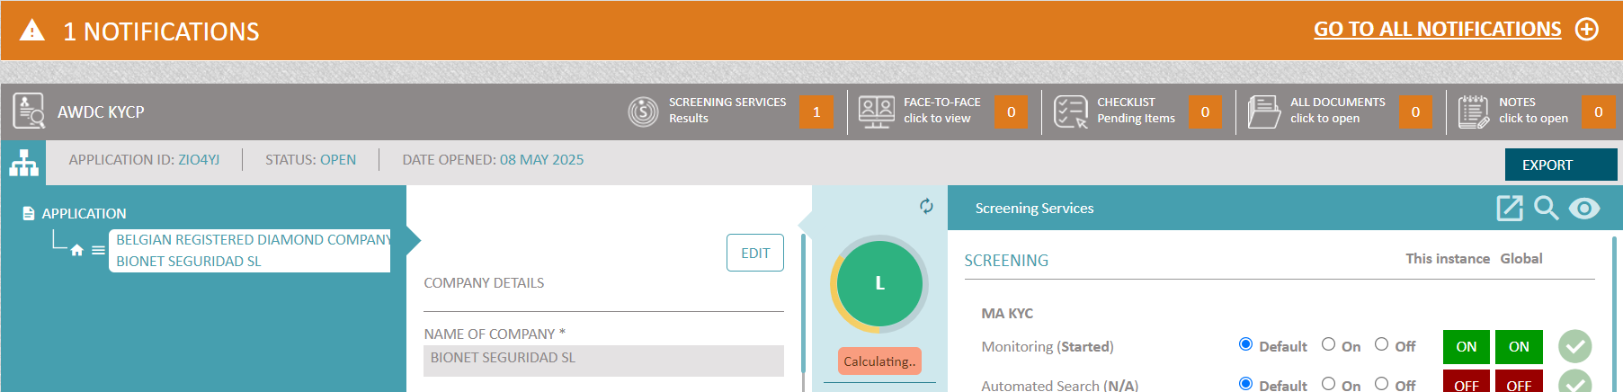

- Note that the fourth column is shows the screening history of the selected entity
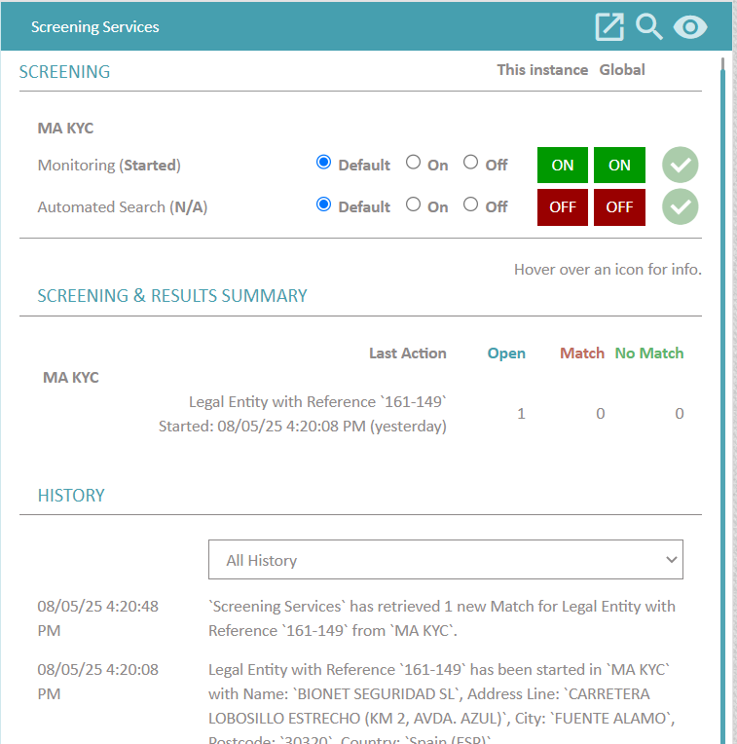
- Press View Match Records icon (circled in red in the image below)
The user will be directed to a new window where discounting / verifying of matches for the selected entity can be made.

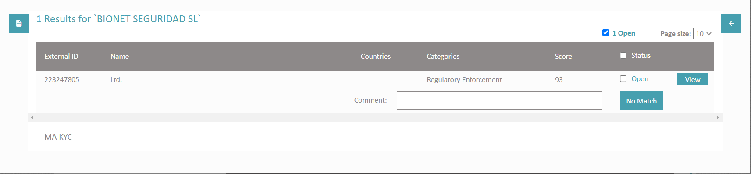
Generate report icon
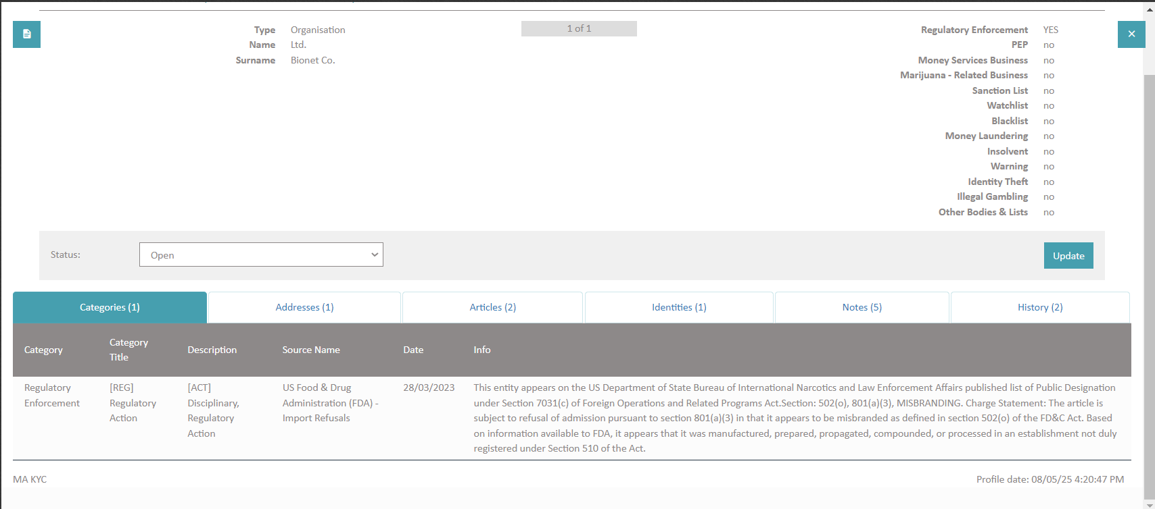
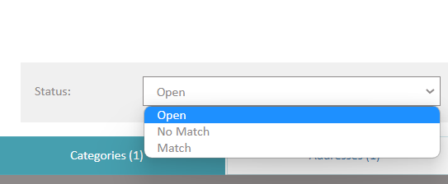
KYCP user, after going through the results, must select 'No Match' or 'Match' to discount or verify respectively

Screening module has also the ability to generate and print a report.
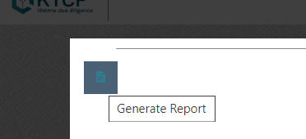
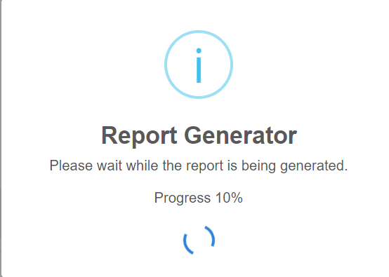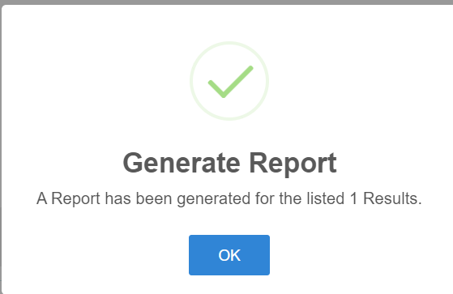

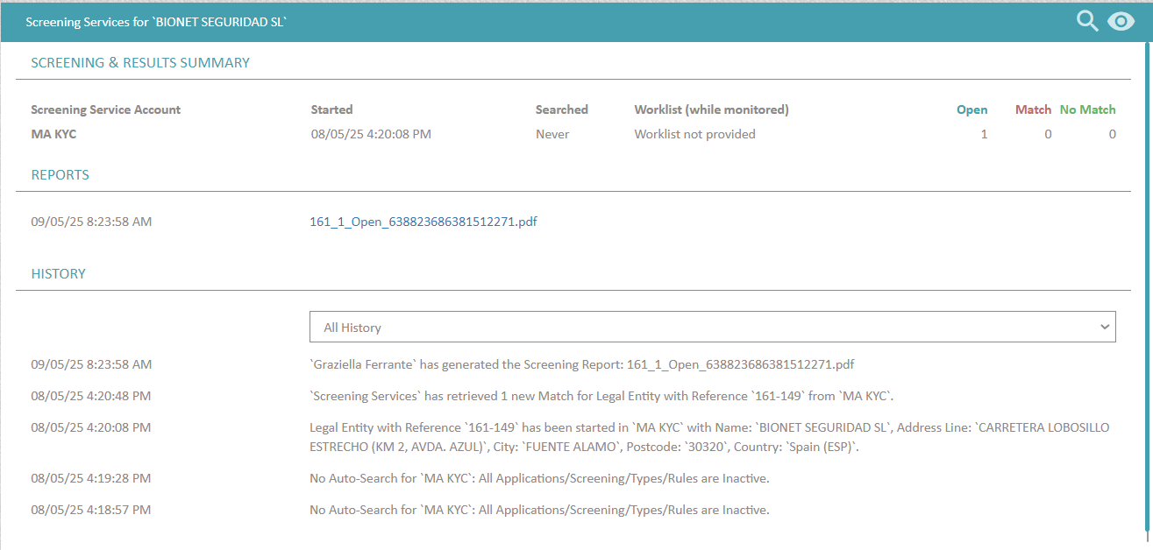
The generated report will be accessible within the history.
screenshot from Screening Services view
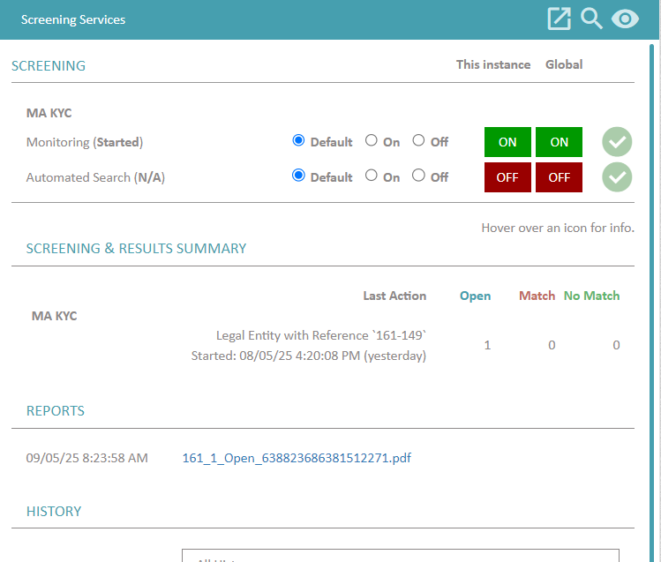
screenshot from Application
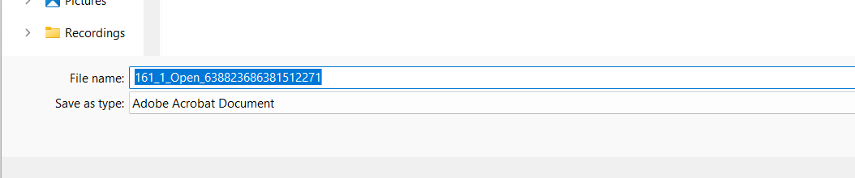
The document can be downloaded and saved to the user's preferred folder. Once downloaded, the user would be able to review the report and print a hard copy.

NB – If the KYCP user selects ‘Match’ the following fields for the entity will be automatically populated.
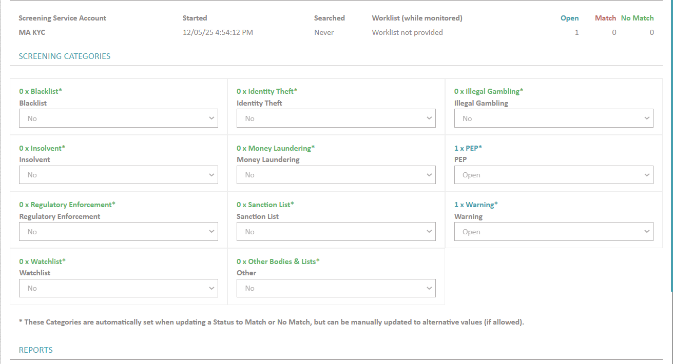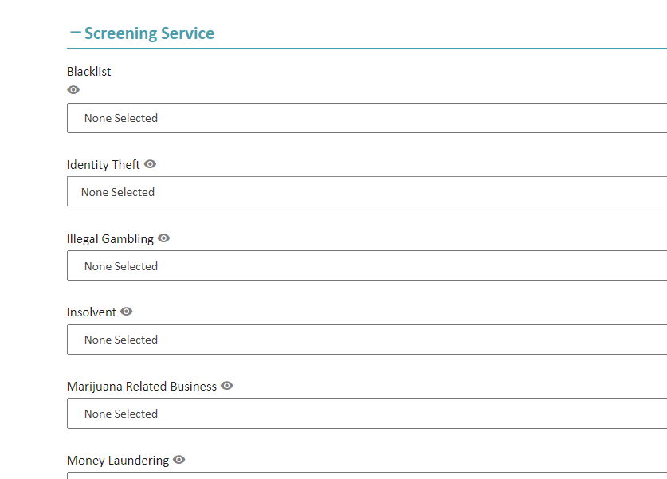

Documents
Documents are a crucial part of any KYC process and due diligence process. Whether you are onboarding an individual or a corporate relationship, documents come in various forms and manners also based on various requirements that evolve over time.
The document management module in KYCP allows you to centralise all documentation on any entity within KYCP itself against an entity. This module however offers many other benefits when it comes to automation of due diligence processes. Here are some of the most important aspects to know about.
Documents can be uploaded to the system by selecting either of the following 3 options:
Option 1: Pressing on ‘All Documents’ found on the grey ribbon
Option 2: Pressing on ‘Linked Documents’/ ‘Upload’ under the Score Dial
Option 3: Pressing on the upload button next to the document type of the selected entity
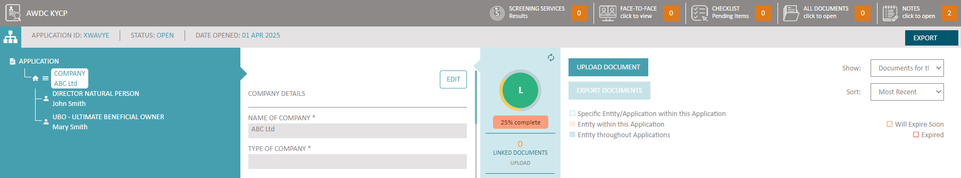
First select ALL DOCUMENTS for upload functionality
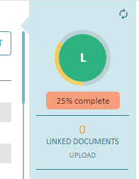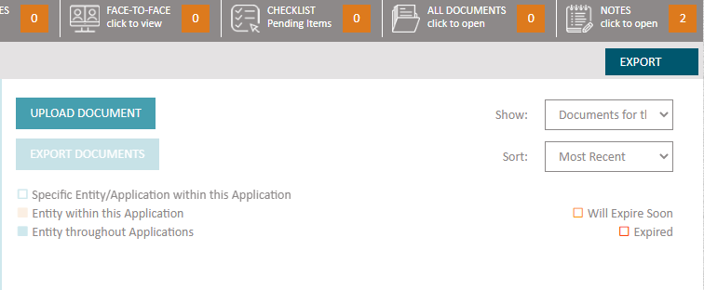
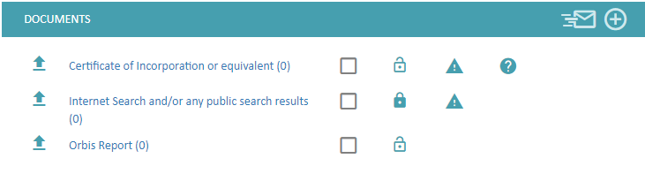
The full list of documents linked to each entity can be found by clicking on ‘CHECKLIST’

Which will open a new window:
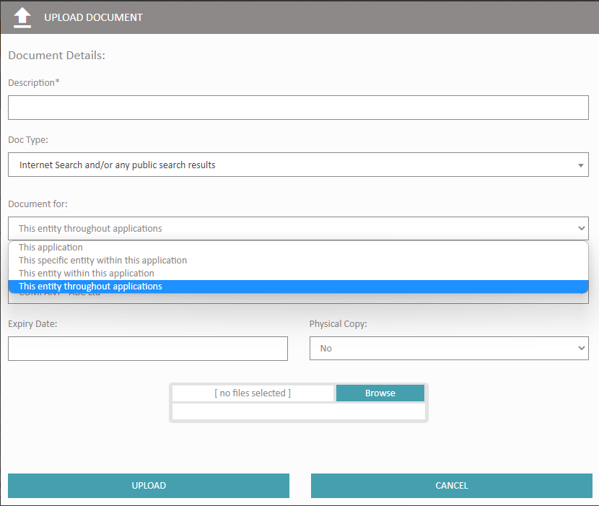
Other icons found next to the Document type:
- refers to further information/help text in relation to the selected document
- open padlock – this type of document is accessible to the client (when using COT)
- closed padlock – this type of document is for internal use only
- warning sign – this type of document is mandatory (i.e., must be uploaded)
Four options are available in the field ‘Document For’:
- This application: the document uploaded will only be displayed within this specific application. [colour code – white]
In the following image, the user uploaded a document using the option ‘This application’. The top ribbon shows the number of documents uploaded. This document is not linked to any entity within this application (as highlighted in the second box)

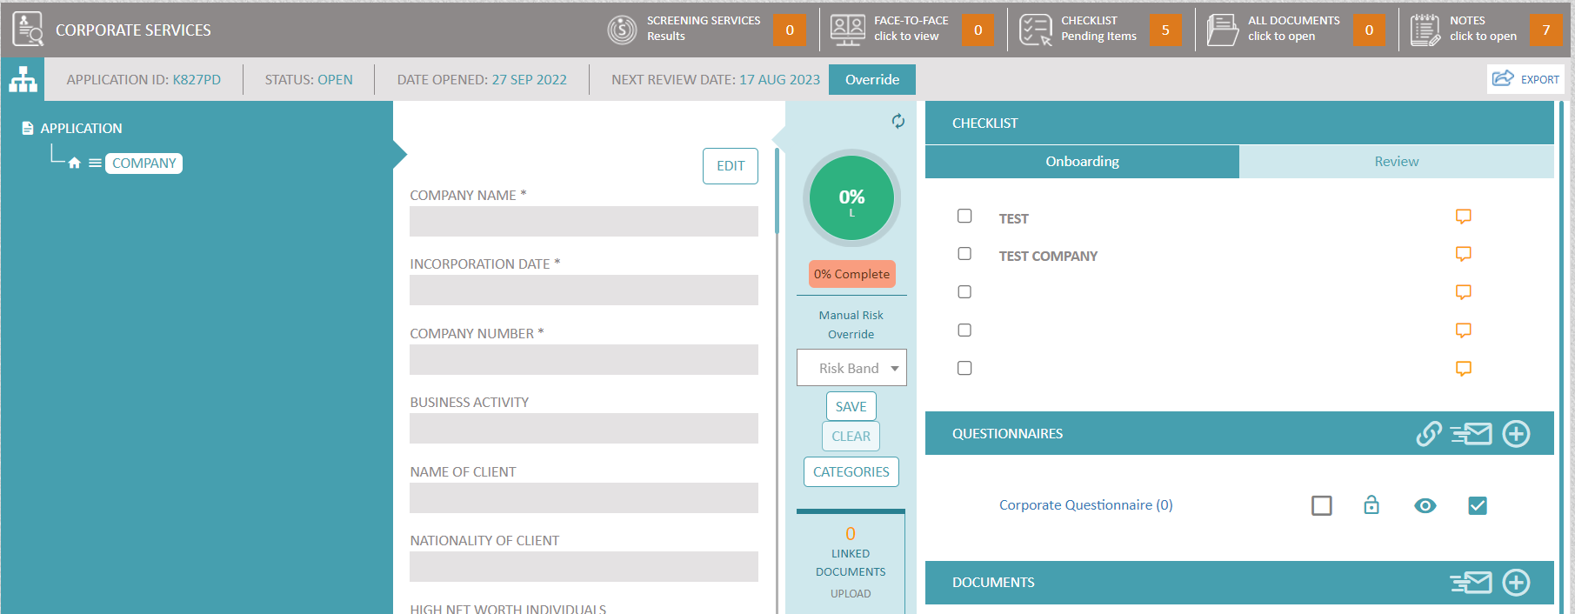
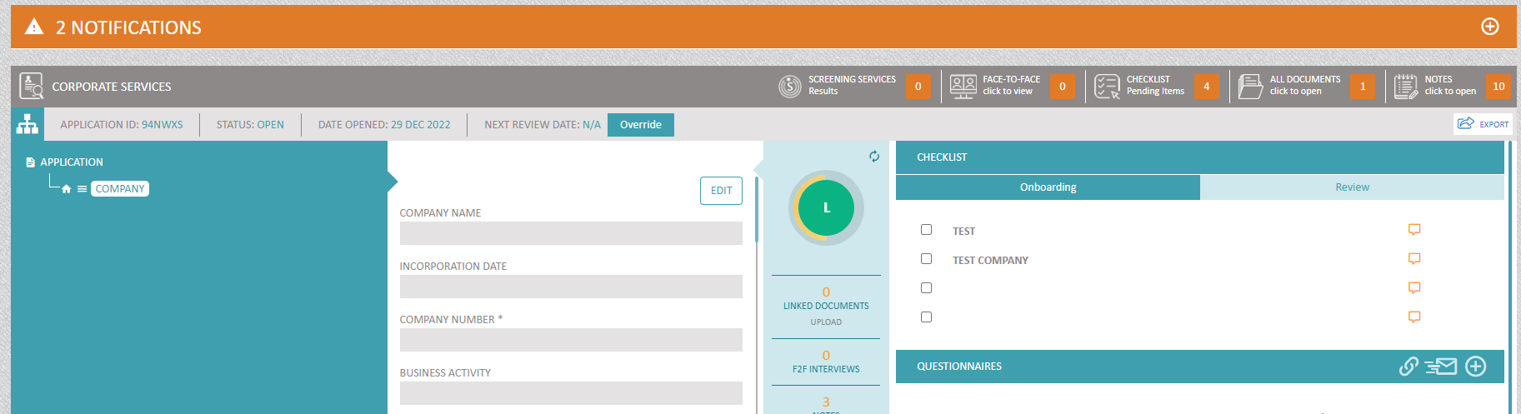

The document can be viewed by clicking on ‘All Document’s from the top ribbon.
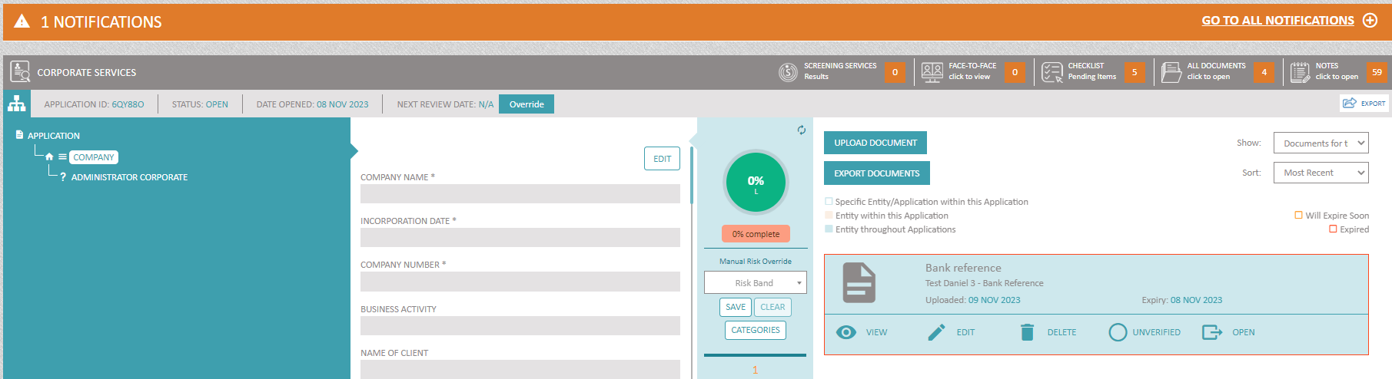

- This specific entity within this application: the document uploaded will only be displayed in this specific entity, within this application. So, if for example you are uploading a document for the UBO, John Smith, in application A, if John also acts as the Director in the same application or he appears in any other applications, this document will not be displayed in these other instances, as it will only be available in the UBO entity for John, in Application A. [colour code – white]
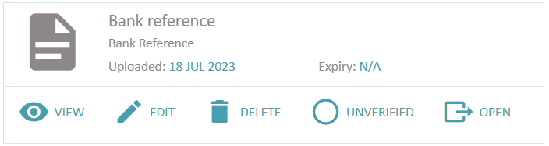
Specific Entity/Application within this Application

- This entity within this application: the document uploaded will be displayed every time this entity appears within this application. So, for example, if you are uploading a document for the UBO, John Smith in application A, and John also appears as the Director in this application, then this document will be displayed with both the UBO and Director entity for John in Application A; however, if John Smith appears in Applications B and C, this document will not be displayed in these two applications. [colour code – amber]
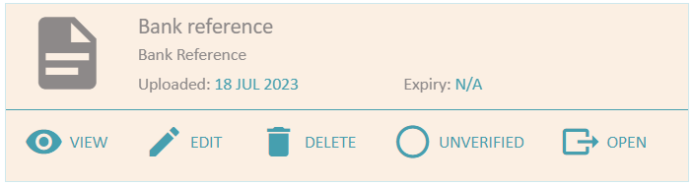
Entity within this Application

- This entity throughout applications: the document uploaded will be displayed wherever this entity exists. So, if John Smith appears as the UBO and Director in Application A, and as a Shareholder in Applications B and C, the document will be displayed in all these entities for John, in these three applications. [colour code – blue]
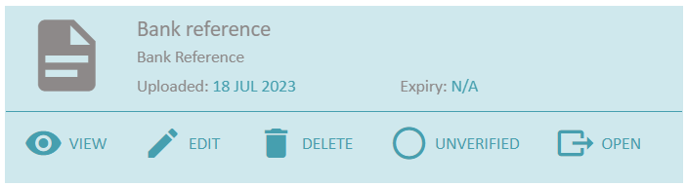
Entity throughout Applications
 or  or 
In the Document tab, the system shows a list of all documents available. If View is clicked , the system will replace this list with the document selected allowing the document to be opened in a new tab. ‘Open’ allows the user to open any document in a new tab without losing the position in the list.

Automated Expiry notifications
When a document is uploaded in KYCP, an expiry date of the document can be inserted. A notification will be fired a number of days before the expiry so that a KYCP user/team can start working on collecting the new version of the document.
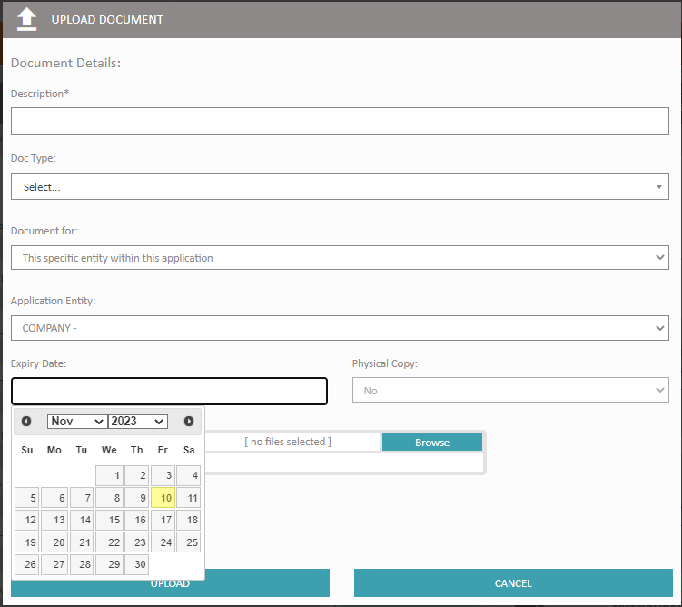

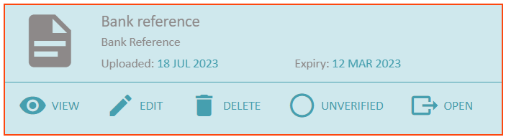
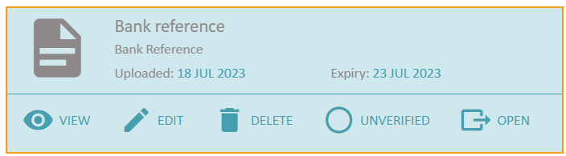

Amber Frame - Document will soon expire

Red Frame - Document expired

Uploading different versions of the same Document Type
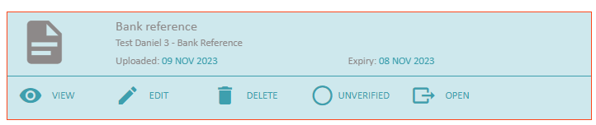
- Click on ‘Edit’
- The system will open a window similar to the window below
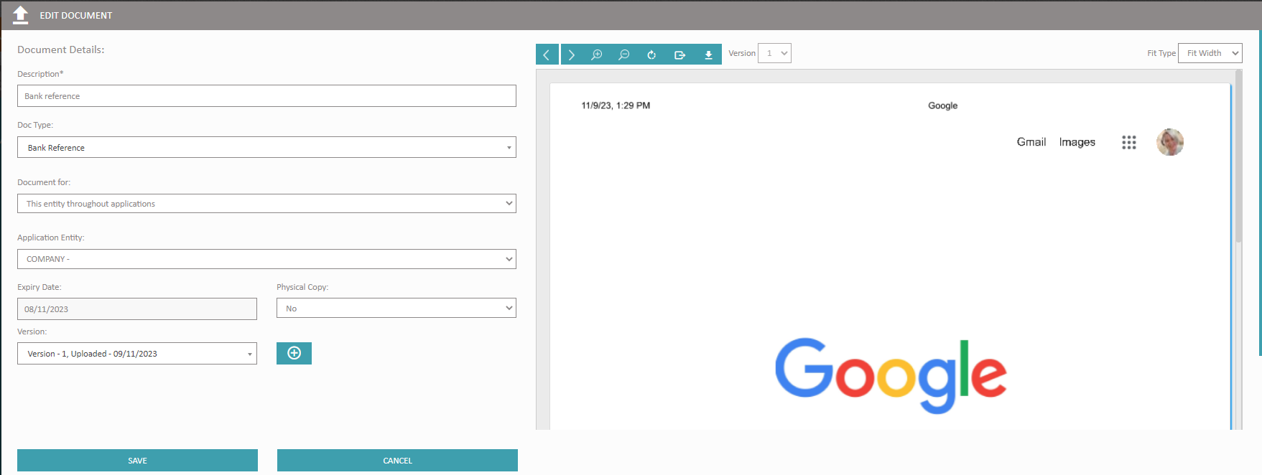
- In this panel the user can select to view different versions of the same ‘Document Type’ or upload a new version.
- To upload a new version, click on the  button
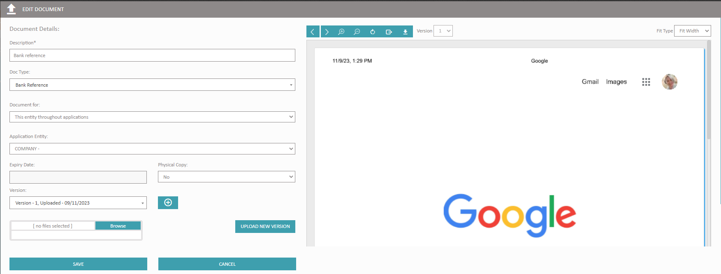

This will open the section where the KYCP user can browse for the new document and upload the new version. For the new version, the KYCP user will be able to set the sharing settings and other settings e.g., ‘Expiry Date’ if applicable.
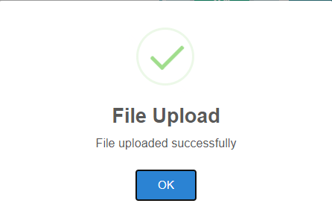

Export all documents in the application

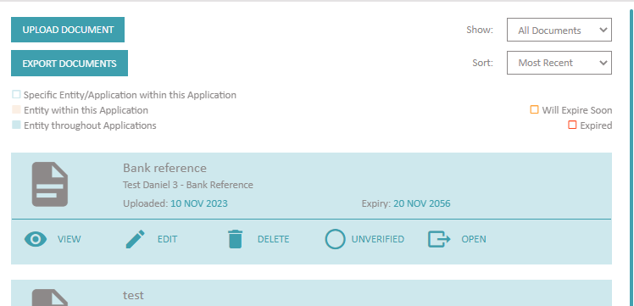
When ‘Export Documents’ is selected, the system will open a window whereby the KYCP user can choose which documents and from which entity, they wish to export.
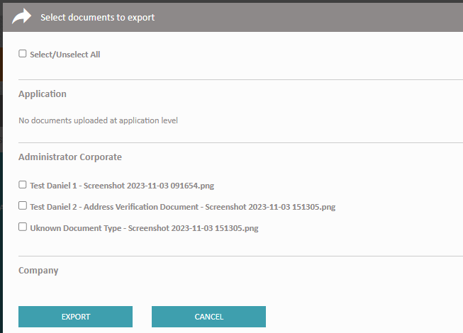
After the selection has been made, the KYCP user will be able to save the zipped folder (containing the exported documents) to their preferred folder.
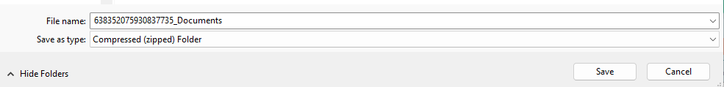

Sorting of Documents with the application and/or entity
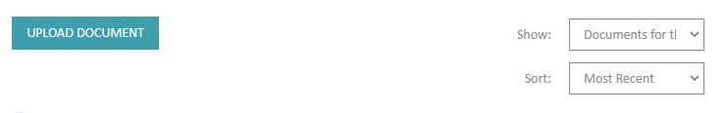
- Show: i) All Documents
ii) Documents for this application entity
- Sort: i) Most Recent (default value)
ii) Oldest
iii) Alphabetical

Single Customer View
The system also allows you to choose whether this document should stick with the entity across your entire KYCP. This is a very powerful feature in order to streamline all documentation by subject across your system. Most clients in fact do set (as a default) that any type of document which is proof of address and proof of ID to stick with the individual wherever they might be in KYCP (even if they show up in the future). This avoids having to ask the same individual or corporate for the documentation that you already have on file, however it also reduces the operational costs of having to keep and verify multiple versions of the same document across your organisation.

Physical Copy
Some companies need to rely on having the physical copy of certain documents throughout the process. KYCP also allows for storing whether the physical copy has been obtained or not to be able to run reports accordingly.

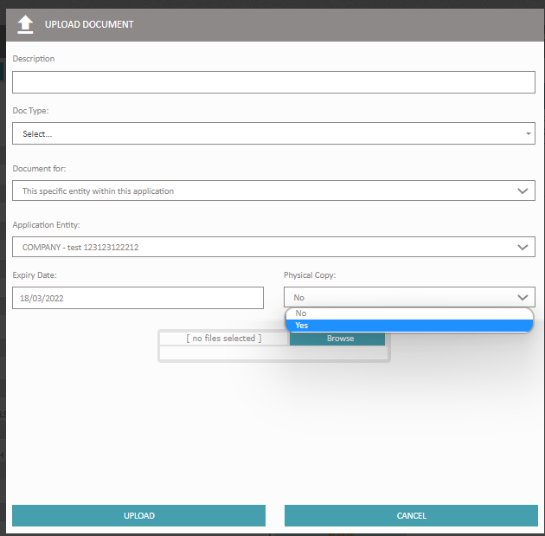

Verification of documents
KYCP also allows the agent / user to be able to mark the authenticity of a document as verified or unverified the authenticity of a document with a manual toggle. A button that allows the user to set the document to VALID or INVALID.
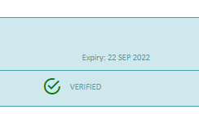
The document module in KYCP allows the user to view and document in the embedded secured viewer. This viewer handles anything from scans, images, PDF, office and similar documents. It also highlights which documents are expired and which documents are about to expire in the short term. If the user has the respective rights, the system also allows for downloading the document to your device.

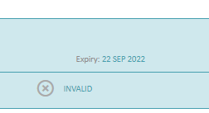
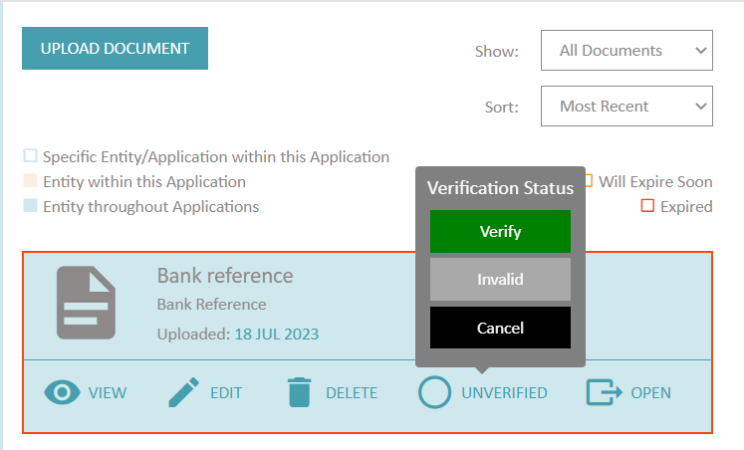

Review in an Application

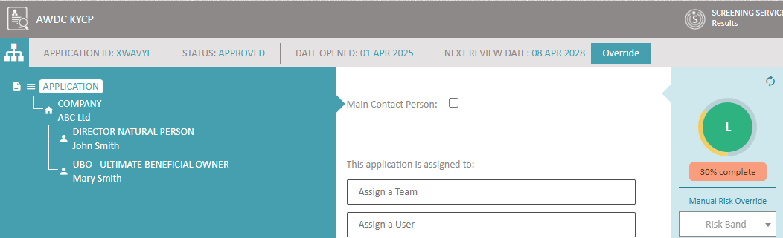
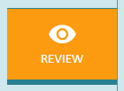
On clicking on 'Review', the next review date is automatically calculated.
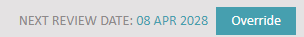
Application showing the next review date. ‘Override’ button allows the user to override the review date (future only)
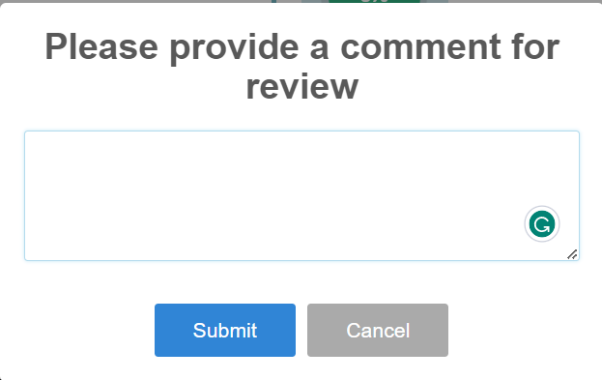
When the 'Review' button is clicked, the system opens a window where the KYCP user can leave a comment regarding this action

Score Dial

The Score Dial is available both at Application Level and again for each entity within the said application.
At application level, the score dial encompasses all the scoring for all the entities, including the categories if this feature has been configured within KYCP.
At entity level, the Score Dial will feature only the score that that particular entity.
Score Dial information can be printed as follows (in the following, the score dial at application level was used but this applies to entities as well).
1 – Select Application, then press on the score dial (circled in red)
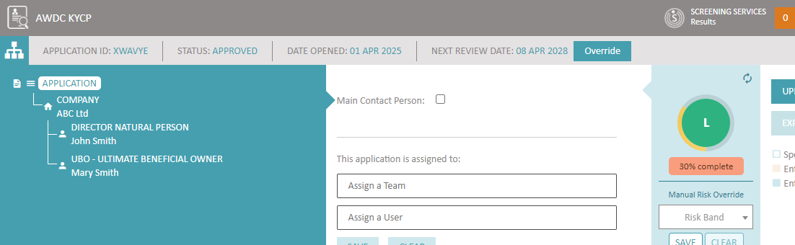

2 – KYCP will open the score history. Use scroll on the right to view all scores or use the print by pressing the print icon. This history can be viewed per hour/day/week etc. NB: if changes are done within the fields, which would result in changes in the score, the history ‘line’ will show a snapshot of how the risk was before the changes were done – including when the ‘current’ is selected.
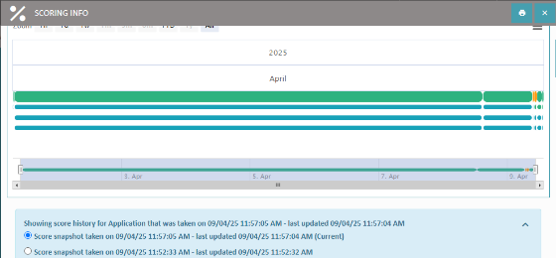
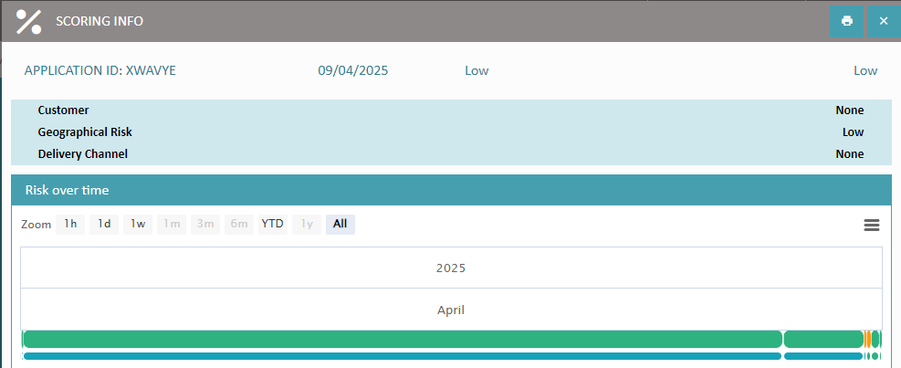
However, the user can change further zoom in for dynamic changes by using the history bar at the bottom.

Printing the Risk Assessment

Printing the Risk Assessment can be done either for an individual entity or at Application level to capture all the entities in the tree structure.
Although the system is programmed to automatically adjust the scoring according to the answers of the populated fields, there would be instances where the users might wish to manually ‘push’ the recalculation.
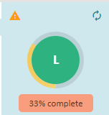
Click this icon for the scoring to be pushed manually
System indication that scoring is still being calculated

On clicking the risk dial, a new window will open (note the 'printer' icon on the right)
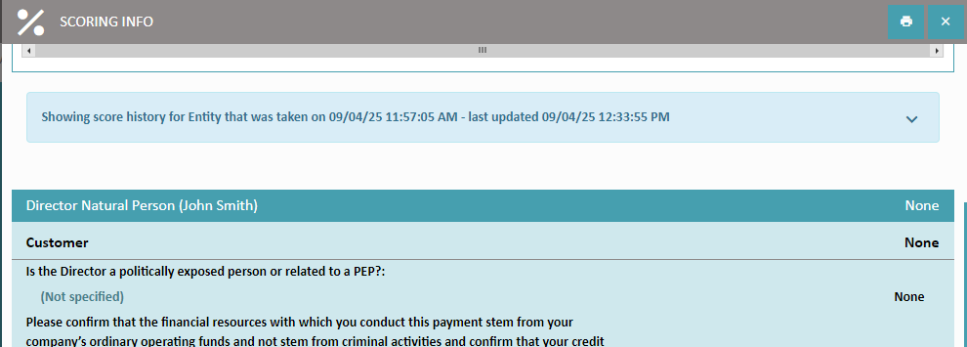

On selecting the 'printer' icon, the user will be given the option to either Save as PDF or Print a hard copy.
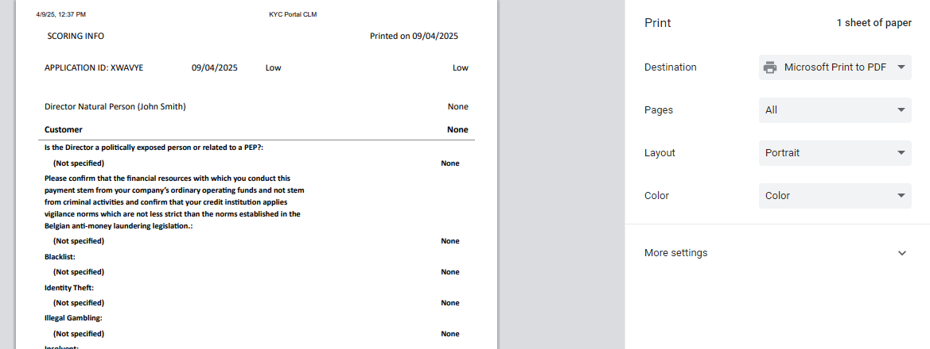
Change in display when Manual Override is done
The information within the Score Dial will show both the original score and the scores which were changed due to a Manuel Override
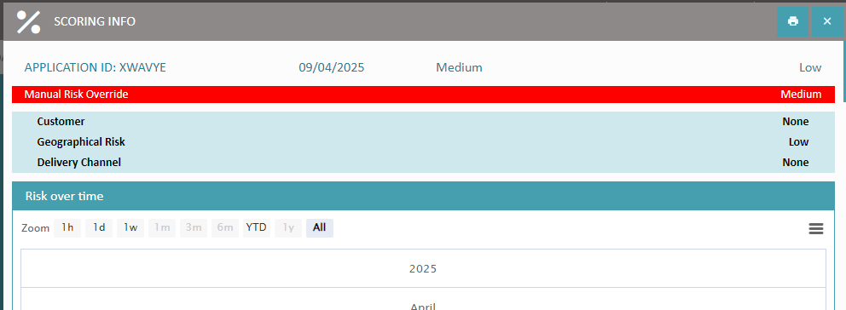

This will also be captured when printing the risk assessment.
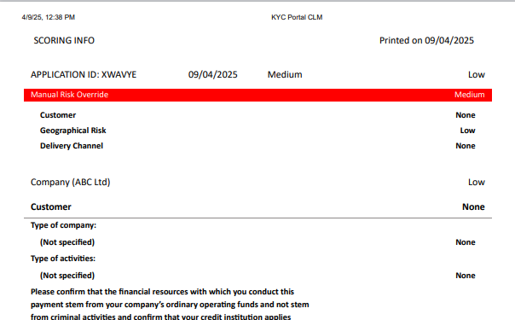

Customer Outreach Tool (COT)

Part of the process is to share the application with your client when, for example, further information is required. Ensure that prior to assigning the application to a COT user, select one of the following COT statuses.
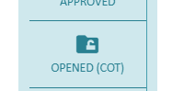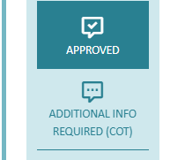
At, Application level, select the COT user and press ‘Save’, followed by ‘Notify COT User’.
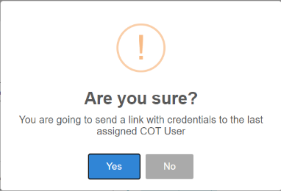
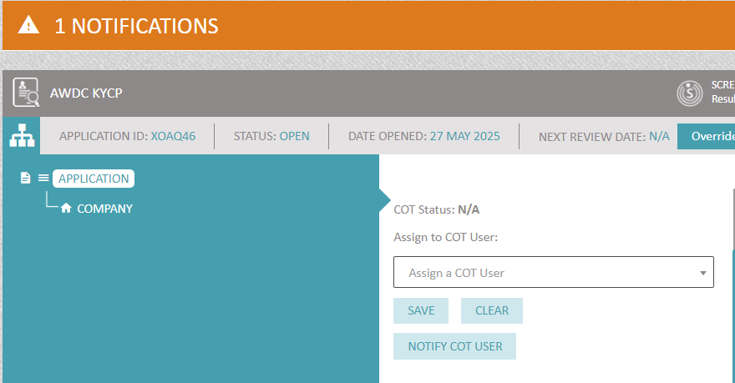
The system will ask the KYCP user if the user wants to proceed with this
action.

The COT user will receive a system generated email with a notification that an application has been assigned to them.
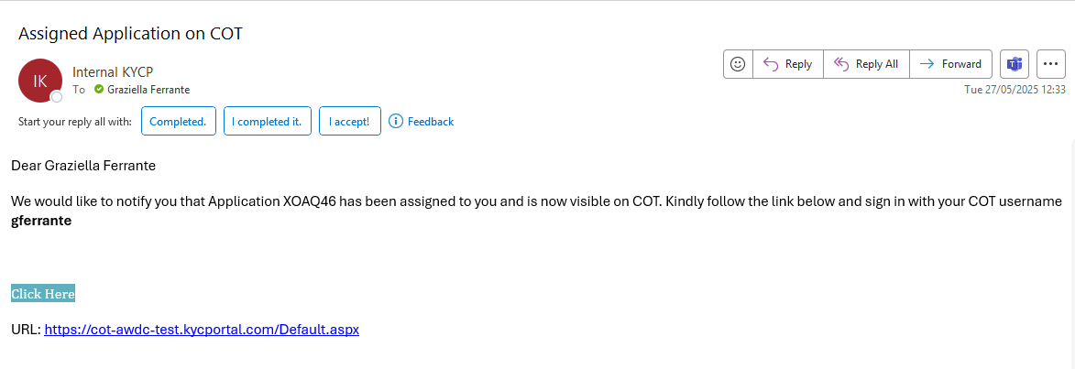

COT USER view
After accessing the link provided in the email, the COT user would need to insert the username and password followed by the Captcha. If this is the first time the COT user is accessing the system, then they would need to enter the username and Captcha followed by ‘Reset my password’

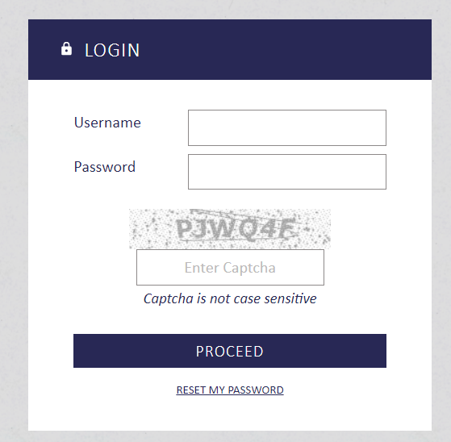
NB – The COT user would have to use the 2-step authentication. There are 3 choices via SMS, email or the user’s preferred authenticator.
In the dashboard, the COT user will be able to see all the applications they’ve been assigned to. When selecting the ‘pen icon’ , the user will be able to work on the assigned application.
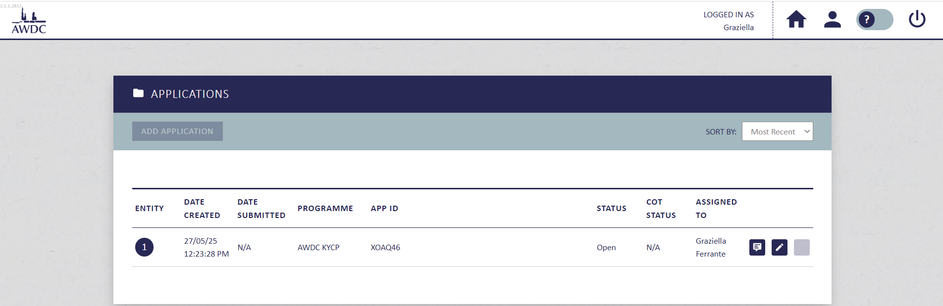
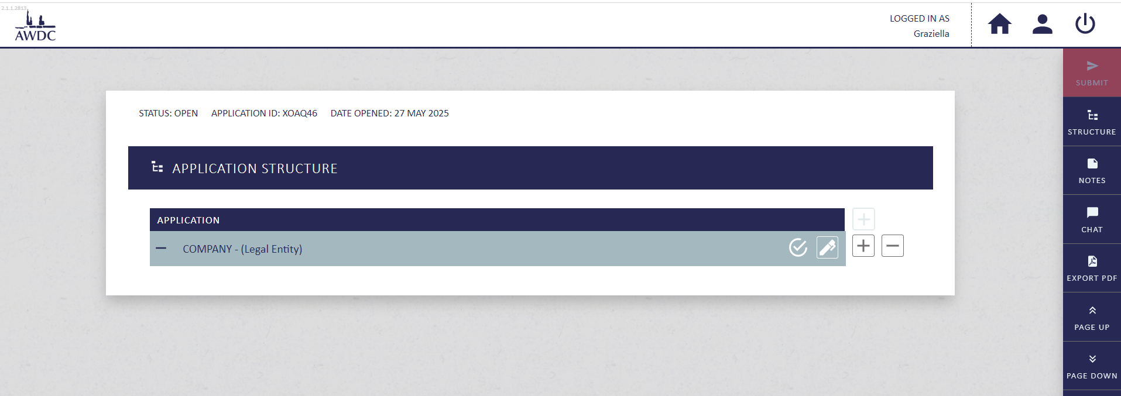
E.g. - by clicking on the '+' icon, the COT user would be able to add more entities
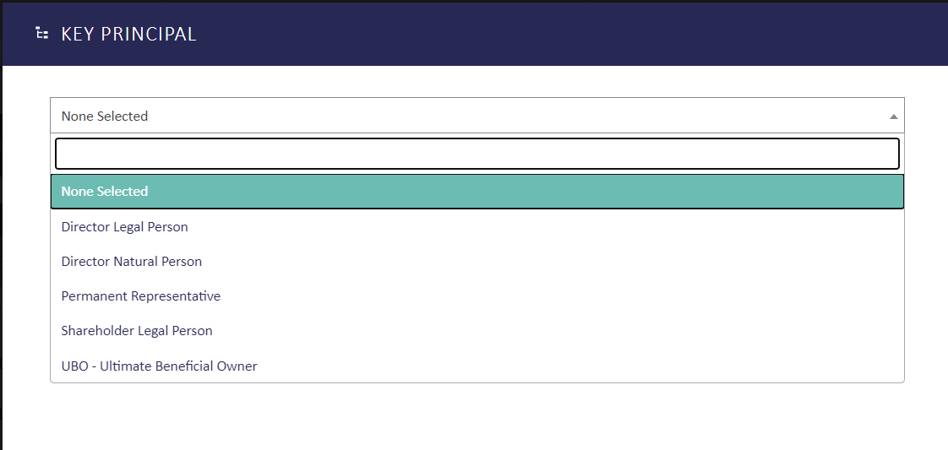
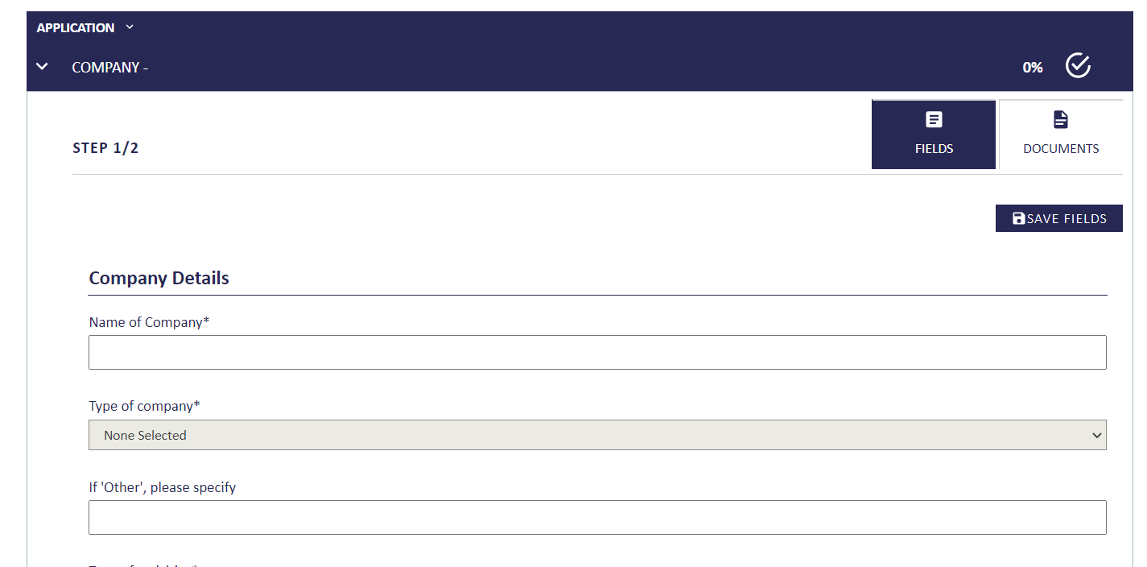
The COT user can fill out any missing details for all the entities within the structure
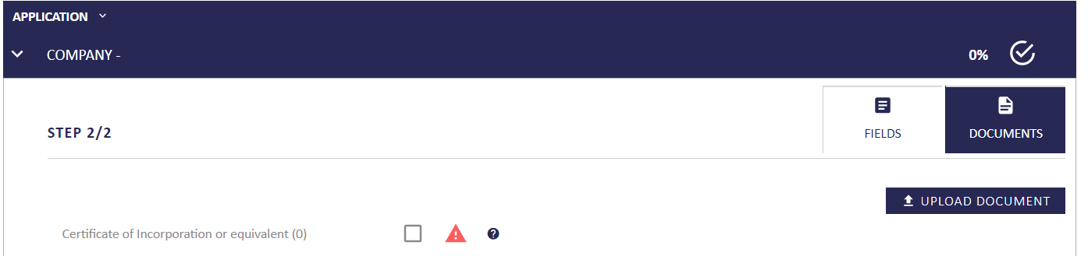
And upload any missing mandatory fields
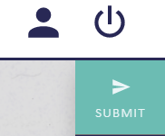 When the COT user has finished filling out all mandatory fields/documents, they will be able to press on ‘Submit’ back to KYCP.
The system will alert the COT user if any mandatory fields and/or documents have been left out, in which case, the COT user would not be able to submit unless all the list provided hasn’t been addressed.
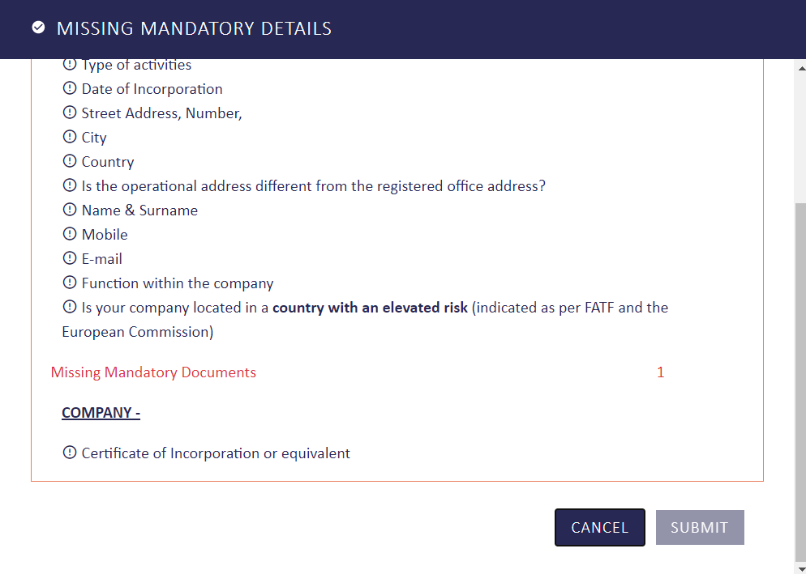

COT Applications

- KYCP ability to search, view, access, edit application/s submitted to COT. This section also includes the information about to whom the application is assigned to.
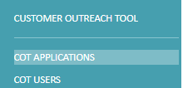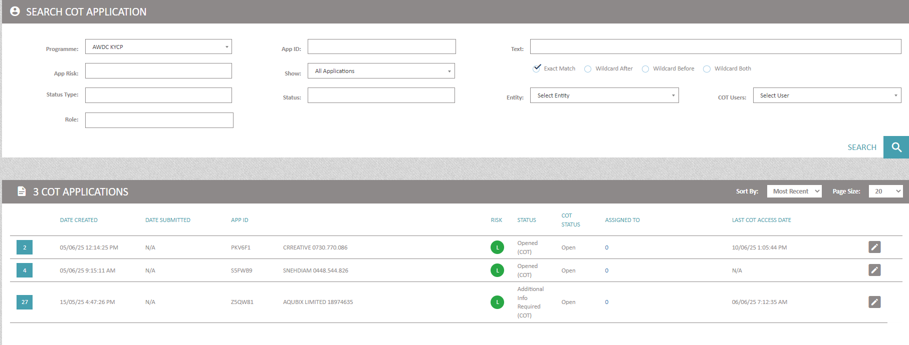

The digit denotes the number of users assigned to the application. When the digit is clicked on, this expands to provide further information on the user/s assigned to the application.

COT Users
KYCP user’s ability to create COT users.
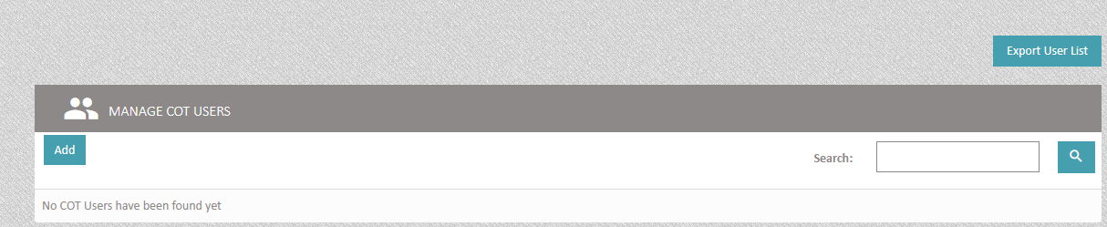
On selecting ‘Add’
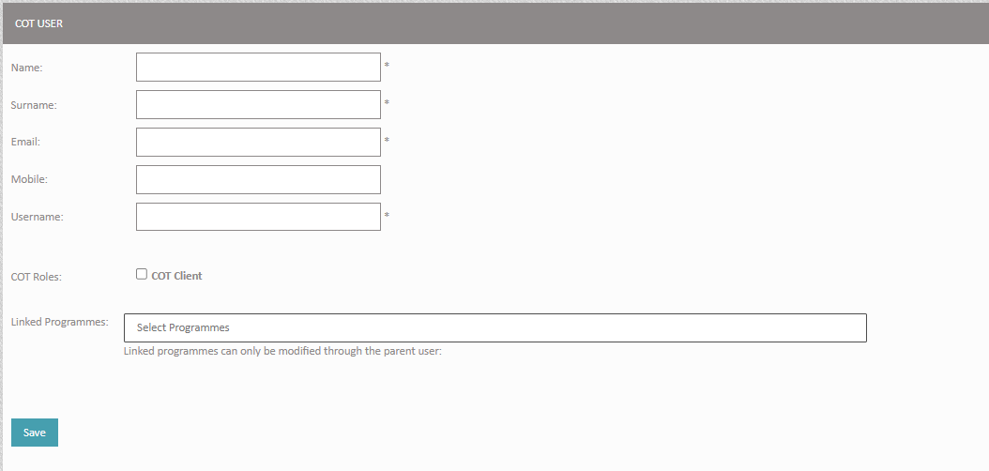
Select pre-determined Role to be given to the COT user
Enter all details for the COT user. Mobile: ensure to populate this with the country code as a prefix without 00 or + e.g. 447911123456

Select which program/s you want to give the COT user access to, to be able to create/edit applications etc

On pressing SAVE, additional fields will pop up
1
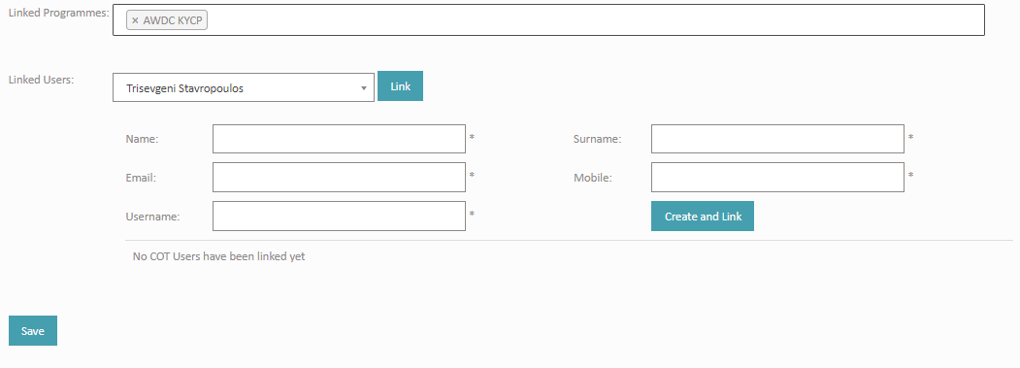
3
2

- KYCP user ability to link other EXISTING COT user/s to the same COT user account
- KYCP user ability to link other NEW COT user/s to the same COT user account
- System alert to show KYCP user if any applications have already been linked to the COT user
After pressing SAVE, send a system generated email to the COT user. Within the email, the COT user will receive a link to reset the password, log in to COT with the given username following the 2-step authentication.

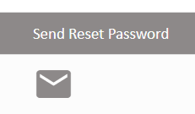
KYCP user can also modify COT user/s by selecting EDIT
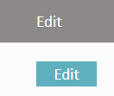

Process - How to onboard a new company in KYCP

- Belgian Registered Diamond Company: If your client is a local Belgian registered diamond.
- Company: If your client is a company (Belgian or foreign, but NOT a Belgian registered diamond company).
- Individual: If your client is a natural person (a private person).
- Trader: This is the KYC page of your own company. Once you complete the fields, you can export the KYC information PDF format. This can be a useful to share with your bank or other stakeholders that need your KYC information.

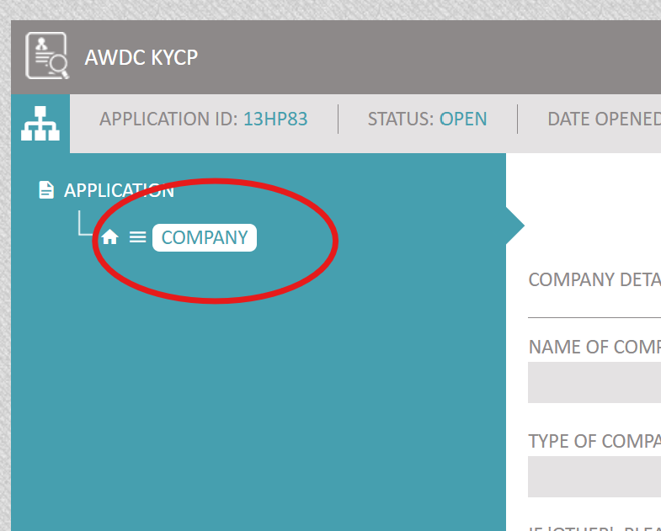
- First click on the selected entity (company, or Belgian registered diamond company or individual) on the left side in the dark blue field

- Then look for the entity in Orbis by pressing 'CSR SEARCH' (see picture below)
- A separate webpage opens
- Enter the company name you are looking for and select the right company (by clicking on the ‘eye’ icon)
- Review the company details (address etc) , also select the PDF Orbis format (obligatory for clients that are Belgian Registered Diamond Companies (!)) and monitoring if you wish -> press IMPORT
- Proceed to structure (select or de-select errors if necessary) and press IMPORT STRUCTURE
- Go back to your KYCP dashboard (different webpage) and REFRESH your webpage (Orbis data are integrated in your application – visible on the left side in the dark blue field)
- Your ORBIS report PDF will also be visible on the right side of the screen if you click first on the name of the company (left).

[Note that this step is not necessary if:
- your client is a Belgian registered diamond company since you only need the Orbis report PDF (downloadable via KYCP end a copy of the UBO register (still needs to be downloaded directly via the UBO register
- your client is a company, but you don’t have any information on your client yet and you wish to go immediately to step 4 to have your client insert the KYC data himself). ]
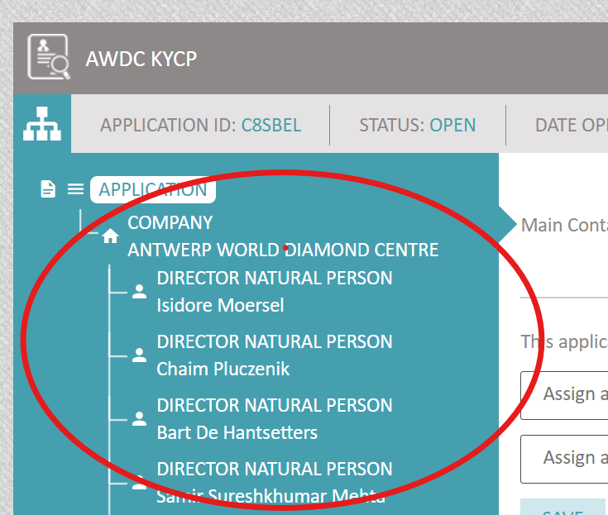
- Click on each entity (entity = the company, directors and UBO’s) separately to complete the fields (click on EDIT) based on information you already might have on your client. If you don’t have any company information on your client yet, you can leave these fields blank, and let your client complete them via the Customer Onboarding Tool (see next steps).
- Some fields should be populated SOLELY by your client (the question on the high risk country and the question on payments)

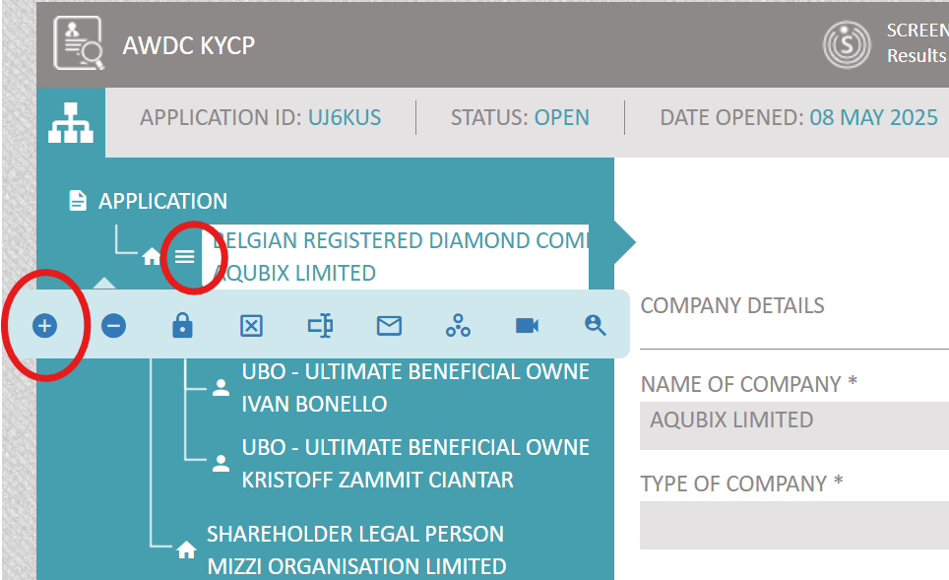

- If you need to add additional directors and/or UBO’s because they were not downloaded (correctly) from ORBIS, click on the 3 lines and click on + (see red circles)
- You will notice some questions under the title ‘screening service’: these will be automatically populated by the GRID screening tool. We recommend to leave these fields blank for now and we revisit these fields later in this onboarding guideline.
- You will also notice some questions under the title ‘risk assessment’. We recommend to leave these fields blank for now and we will revisit these fields later in this onboarding guideline.

[Note that this step is not necessary if your client is a Belgian registered diamond company since you only need the Orbis report PDF (downloadable via KYCP end a copy of the UBO register (still needs to be downloaded directly via the UBO register).]

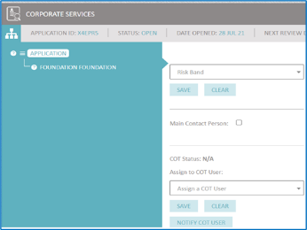

- Part of the process is to share the application with your client so he/she can complete the KYC information and upload all required documents (ID cards, bylaws,..). Ensure that prior to assigning the application to a COT user, select one of the following COT statuses.

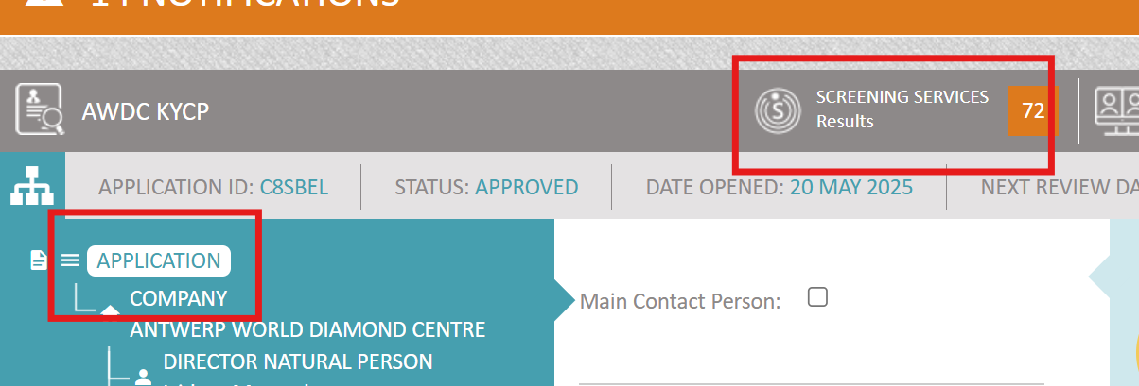
- First click on ‘application’ on the left side in the dark blue field
- Then click on ‘screening services’

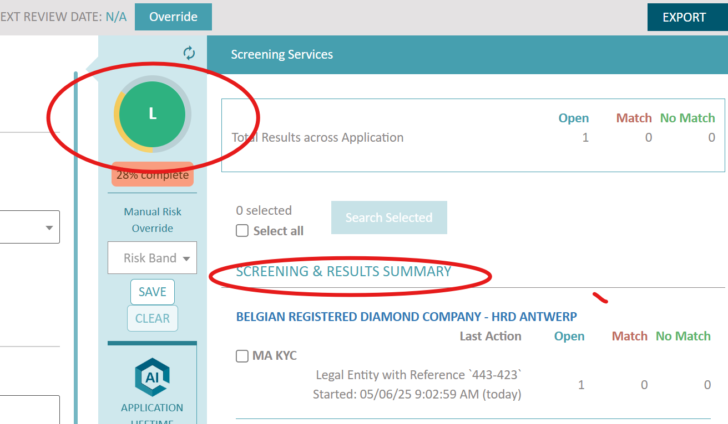

- On the right side you will notice the ‘screening & results summary ‘appear [ sometimes this can take a few minutes, refresh regularly by clicking on the coloured (green, orange or red) risk circle in the middle!]
  - Open= means how many potential matches the system has
  - Match= a number will only appear if you accepted a potential match
  - NO match= a number will only appear if you rejected a potential match
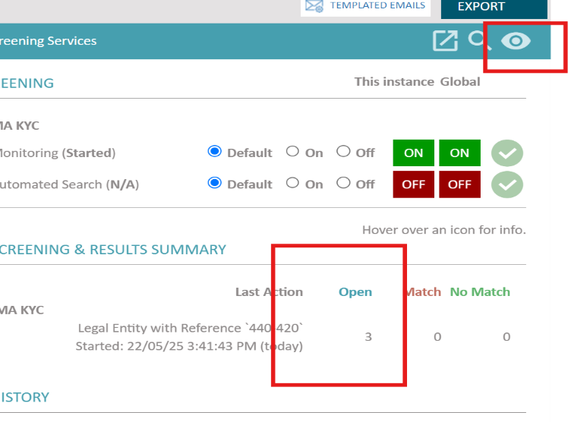
- In this example, you can see 3 potential matches. Click on the eye in the top right corner (depending on what entity you have selected, the eye may not always be visible, but the company name or directors name might then be ‘clickable’ instead.
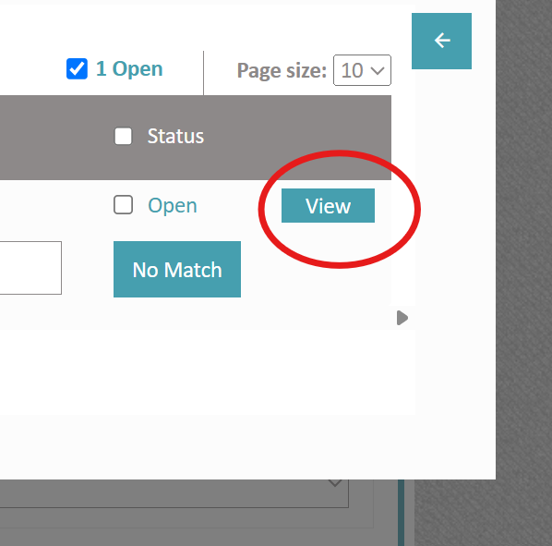

- A separate webpage opens
- Click on VIEW
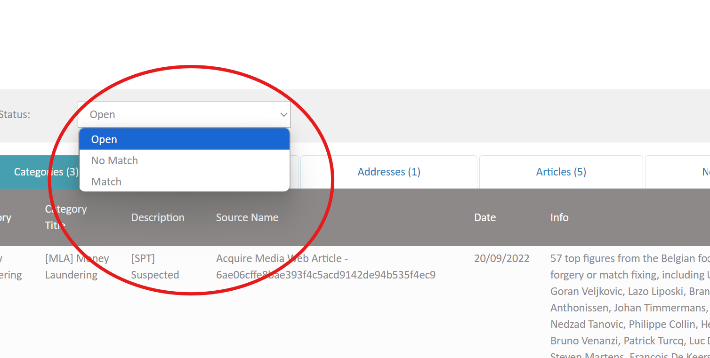

- Go through the potential matches, read them and select MATCH or NO MATCH and click on UPDATE

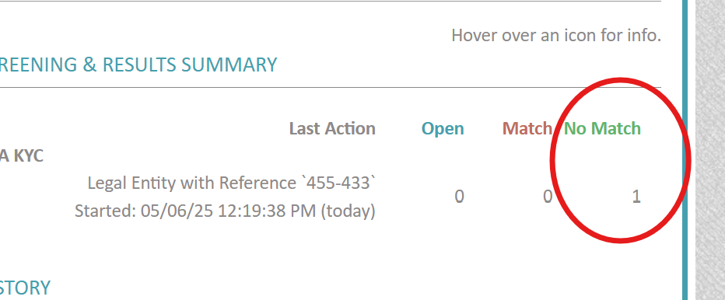

- Go again to your KYCP webpage, refresh the webpage and go to screening services: accepted or rejected matched should be visible now

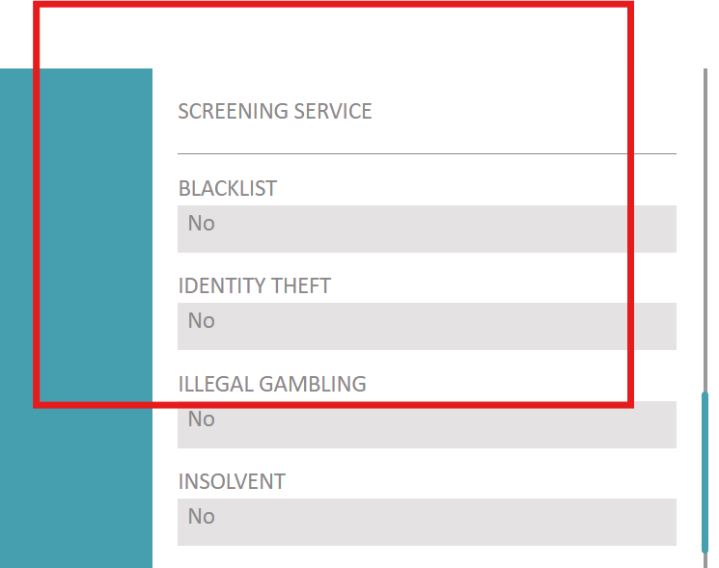

- The field under ‘screening service’ when you click on ‘company’ (left top side in dark blue field), will now also be automatically completed (sometimes you need to refresh multiple times!)

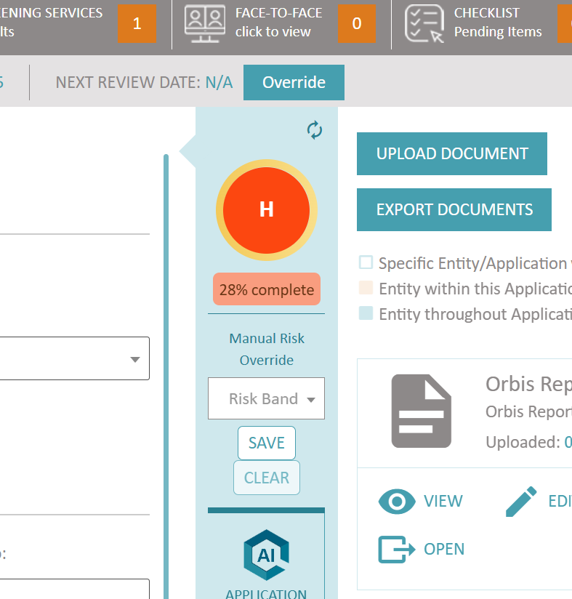
- The risk screening may have impacted the risk score of your client. The risk score is indicated in the middle of your screen: a green circle (low risk), orange circle (medium risk), red circle (high risk).
- You can manually override your risk score only by clicking on ‘risk band’ and selecting a different risk scoring (low, medium, high)
- Regularly refresh your risk scoring by clicking on the two arrows on the right side of the circle

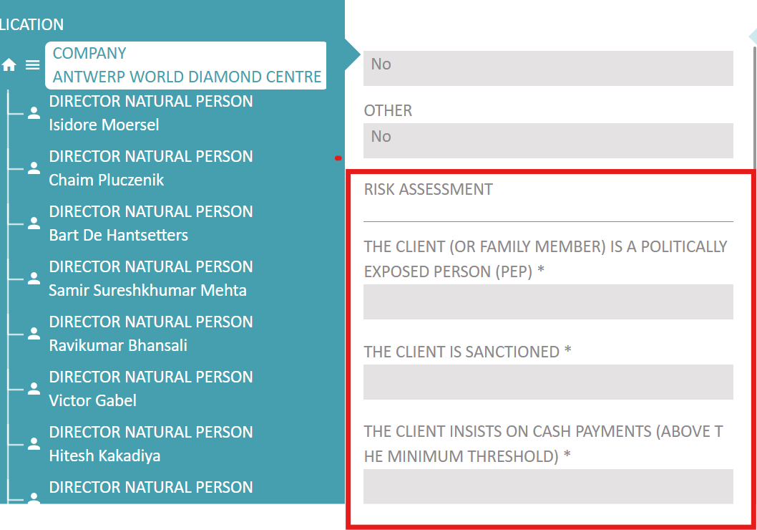

- Click on the name of the company on the left side in the dark blue field
- Complete the risk assessment questions by clicking on EDIT first
- Your answers to these questions may impact your risk scoring again (refresh the coloured circle in the middle of your screen regularly)

